Mass pair ID: 0  
Compound id: 10

|  |  |  |  |  |
| --- | --- | --- | --- | --- |
|  | peak_height | peak_width | peak_area | peak_position |
| count | 58.000000 | 58.000000 | 58.000000 | 58.000000 |
| mean | 11550.699613 | 2.947469 | 24126.172809 | 9.603448 |
| std | 21829.875428 | 0.466799 | 45804.076400 | 3.631923 |
| min | 161.671196 | 2.455954 | 504.394940 | 7.000000 |
| 25% | 775.652289 | 2.720582 | 2211.525918 | 8.000000 |
| 50% | 3186.260561 | 2.839728 | 7821.474898 | 9.000000 |
| 75% | 12483.160226 | 3.170623 | 24369.551928 | 9.000000 |
| max | 113501.014255 | 5.594501 | 235102.816555 | 24.000000 |

Mass pair ID: 2  
Compound id: 4

|  |  |  |  |  |
| --- | --- | --- | --- | --- |
|  | peak_height | peak_width | peak_area | peak_position |
| count | 7.500000e+01 | 75.000000 | 7.500000e+01 | 75.000000 |
| mean | 1.222119e+06 | 13.997053 | 1.020967e+07 | 14.840000 |
| std | 1.428405e+06 | 2.094582 | 1.130238e+07 | 2.922605 |
| min | 8.705637e+03 | 7.493258 | 8.443583e+04 | 10.000000 |
| 25% | 3.823921e+05 | 12.625422 | 3.085438e+06 | 13.000000 |
| 50% | 8.582706e+05 | 13.928521 | 8.009356e+06 | 14.000000 |
| 75% | 1.510735e+06 | 15.546636 | 1.311979e+07 | 16.000000 |
| max | 7.812279e+06 | 18.818824 | 5.996655e+07 | 24.000000 |

Mass pair ID: 3  
Compound id: 10

|  |  |  |  |  |
| --- | --- | --- | --- | --- |
|  | peak_height | peak_width | peak_area | peak_position |
| count | 58.000000 | 58.000000 | 58.000000 | 58.000000 |
| mean | 2394.239806 | 4.140446 | 6999.662056 | 11.586207 |
| std | 3848.098654 | 2.501450 | 8324.895862 | 5.143671 |
| min | 232.034191 | 2.458624 | 712.747770 | 7.000000 |
| 25% | 502.073760 | 2.811514 | 2499.255030 | 8.000000 |
| 50% | 916.222353 | 3.017299 | 4009.936668 | 9.000000 |
| 75% | 2155.255170 | 3.790881 | 8221.065088 | 12.750000 |
| max | 19697.147224 | 12.807715 | 45066.008653 | 26.000000 |

Mass pair ID: 4  
Compound id: 10

|  |  |  |  |  |
| --- | --- | --- | --- | --- |
|  | peak_height | peak_width | peak_area | peak_position |
| count | 5.800000e+01 | 58.000000 | 5.800000e+01 | 58.000000 |
| mean | 1.742153e+05 | 2.890880 | 3.500940e+05 | 8.551724 |
| std | 3.055890e+05 | 0.180269 | 6.201140e+05 | 1.778748 |
| min | 3.250899e+02 | 2.453575 | 7.748027e+02 | 7.000000 |
| 25% | 9.616824e+03 | 2.802679 | 2.036929e+04 | 8.000000 |
| 50% | 4.689655e+04 | 2.892822 | 9.500289e+04 | 8.000000 |
| 75% | 1.902662e+05 | 2.970350 | 3.593384e+05 | 9.000000 |
| max | 1.440630e+06 | 3.353485 | 2.892788e+06 | 21.000000 |

Mass pair ID: 7  
Compound id: 19

|  |  |  |  |  |
| --- | --- | --- | --- | --- |
|  | peak_height | peak_width | peak_area | peak_position |
| count | 4.000000 | 4.000000 | 4.000000e+00 | 4.000000 |
| mean | 543430.037354 | 9.375763 | 3.378096e+06 | 9.250000 |
| std | 219256.562660 | 2.159290 | 1.378049e+06 | 0.957427 |
| min | 290126.344881 | 7.806395 | 1.687921e+06 | 8.000000 |
| 25% | 441122.107843 | 8.190122 | 2.634308e+06 | 8.750000 |
| 50% | 531755.701796 | 8.571265 | 3.466379e+06 | 9.500000 |
| 75% | 634063.631307 | 9.756907 | 4.210167e+06 | 10.000000 |
| max | 820082.400943 | 12.554128 | 4.891705e+06 | 10.000000 |

Mass pair ID: 8  
Compound id: 19

|  |  |  |  |  |
| --- | --- | --- | --- | --- |
|  | peak_height | peak_width | peak_area | peak_position |
| count | 4.000000 | 4.000000 | 4.000000e+00 | 4.000000 |
| mean | 200977.214796 | 9.386097 | 1.246179e+06 | 9.250000 |
| std | 77478.346994 | 2.103321 | 5.000883e+05 | 0.957427 |
| min | 111684.718303 | 7.812197 | 6.478259e+05 | 8.000000 |
| 25% | 165794.922701 | 8.351683 | 9.579853e+05 | 8.750000 |
| 50% | 196438.982690 | 8.622817 | 1.269398e+06 | 9.500000 |
| 75% | 231621.274786 | 9.657231 | 1.557592e+06 | 10.000000 |
| max | 299346.175503 | 12.486556 | 1.798094e+06 | 10.000000 |

Mass pair ID: 11  
Compound id: 4

|  |  |  |  |  |
| --- | --- | --- | --- | --- |
|  | peak_height | peak_width | peak_area | peak_position |
| count | 7.500000e+01 | 75.000000 | 7.500000e+01 | 75.000000 |
| mean | 7.515866e+06 | 7.500856 | 3.112777e+07 | 10.120000 |
| std | 1.472584e+07 | 2.938236 | 5.451120e+07 | 1.770326 |
| min | 3.171780e+03 | 3.684442 | 3.070851e+04 | 8.000000 |
| 25% | 3.178175e+05 | 5.295238 | 2.092234e+06 | 9.000000 |
| 50% | 1.584894e+06 | 6.866681 | 9.854158e+06 | 10.000000 |
| 75% | 7.409986e+06 | 8.685017 | 3.479238e+07 | 11.000000 |
| max | 8.349197e+07 | 18.100199 | 3.101983e+08 | 16.000000 |

Mass pair ID: 16  
Compound id: 14

|  |  |  |  |  |
| --- | --- | --- | --- | --- |
|  | peak_height | peak_width | peak_area | peak_position |
| count | 3.600000e+01 | 36.000000 | 3.600000e+01 | 36.000000 |
| mean | 2.967178e+06 | 9.655698 | 2.595272e+07 | 10.500000 |
| std | 2.819156e+06 | 4.850498 | 2.760304e+07 | 2.677952 |
| min | 1.810196e+05 | 2.944458 | 4.267900e+05 | 7.000000 |
| 25% | 4.159634e+05 | 5.107734 | 1.637275e+06 | 8.000000 |
| 50% | 2.086791e+06 | 10.485256 | 1.710200e+07 | 10.000000 |
| 75% | 5.324451e+06 | 14.530156 | 4.244696e+07 | 12.250000 |
| max | 8.509852e+06 | 18.390611 | 8.495161e+07 | 17.000000 |

Mass pair ID: 16  
Compound id: 7

|  |  |  |  |  |
| --- | --- | --- | --- | --- |
|  | peak_height | peak_width | peak_area | peak_position |
| count | 9.000000e+00 | 9.000000 | 9.000000e+00 | 9.000000 |
| mean | 6.386698e+07 | 4.442566 | 2.240194e+08 | 7.555556 |
| std | 2.711744e+07 | 0.753150 | 1.149507e+08 | 0.881917 |
| min | 1.263006e+07 | 2.614652 | 2.144087e+07 | 6.000000 |
| 25% | 5.019006e+07 | 4.545878 | 1.668317e+08 | 7.000000 |
| 50% | 6.700041e+07 | 4.690279 | 2.223790e+08 | 8.000000 |
| 75% | 7.976908e+07 | 4.842519 | 2.842765e+08 | 8.000000 |
| max | 1.058004e+08 | 5.091974 | 4.285697e+08 | 9.000000 |

Mass pair ID: 16  
Compound id: 8

|  |  |  |  |  |
| --- | --- | --- | --- | --- |
|  | peak_height | peak_width | peak_area | peak_position |
| count | 5.800000e+01 | 58.000000 | 5.800000e+01 | 58.000000 |
| mean | 1.568260e+06 | 8.571021 | 1.052365e+07 | 9.000000 |
| std | 9.014707e+05 | 4.055719 | 7.738931e+06 | 2.008753 |
| min | 3.377495e+05 | 2.665711 | 8.617611e+05 | 6.000000 |
| 25% | 9.950637e+05 | 6.220393 | 5.195725e+06 | 8.000000 |
| 50% | 1.290840e+06 | 8.170008 | 8.201630e+06 | 9.000000 |
| 75% | 1.887694e+06 | 10.757524 | 1.359228e+07 | 9.750000 |
| max | 4.148422e+06 | 20.296718 | 3.221484e+07 | 21.000000 |

Mass pair ID: 18  
Compound id: 14

|  |  |  |  |  |
| --- | --- | --- | --- | --- |
|  | peak_height | peak_width | peak_area | peak_position |
| count | 3.600000e+01 | 36.000000 | 3.600000e+01 | 36.000000 |
| mean | 7.407487e+05 | 11.658412 | 6.313986e+06 | 10.527778 |
| std | 5.427309e+05 | 4.787521 | 4.839979e+06 | 1.539687 |
| min | 1.177058e+05 | 4.994515 | 3.953604e+05 | 9.000000 |
| 25% | 2.304957e+05 | 7.708109 | 1.799347e+06 | 10.000000 |
| 50% | 6.735404e+05 | 9.927625 | 5.961629e+06 | 10.000000 |
| 75% | 1.302438e+06 | 16.695908 | 1.077006e+07 | 11.000000 |
| max | 1.806910e+06 | 20.288940 | 1.447994e+07 | 16.000000 |

Mass pair ID: 18  
Compound id: 7

|  |  |  |  |  |
| --- | --- | --- | --- | --- |
|  | peak_height | peak_width | peak_area | peak_position |
| count | 9.000000e+00 | 9.000000 | 9.000000e+00 | 9.000000 |
| mean | 2.131112e+07 | 4.074560 | 6.625707e+07 | 7.777778 |
| std | 9.272220e+06 | 0.555329 | 3.037827e+07 | 0.833333 |
| min | 9.669997e+06 | 3.147055 | 2.071504e+07 | 6.000000 |
| 25% | 1.609312e+07 | 3.885655 | 5.402813e+07 | 8.000000 |
| 50% | 2.185067e+07 | 3.984346 | 6.569613e+07 | 8.000000 |
| 75% | 2.233894e+07 | 4.347974 | 6.898221e+07 | 8.000000 |
| max | 4.219839e+07 | 5.168316 | 1.350991e+08 | 9.000000 |

Mass pair ID: 18  
Compound id: 8

|  |  |  |  |  |
| --- | --- | --- | --- | --- |
|  | peak_height | peak_width | peak_area | peak_position |
| count | 5.800000e+01 | 58.000000 | 5.800000e+01 | 58.000000 |
| mean | 4.994707e+05 | 5.435087 | 2.272742e+06 | 10.275862 |
| std | 3.487154e+05 | 3.417836 | 1.765104e+06 | 5.369809 |
| min | 4.092446e+04 | 2.452172 | 6.380462e+04 | 6.000000 |
| 25% | 2.852682e+05 | 3.192881 | 9.139663e+05 | 7.000000 |
| 50% | 3.539890e+05 | 4.068656 | 1.847894e+06 | 8.000000 |
| 75% | 7.015402e+05 | 6.353337 | 3.037407e+06 | 10.000000 |
| max | 1.807145e+06 | 19.590298 | 7.865656e+06 | 26.000000 |

Mass pair ID: 19  
Compound id: 10

|  |  |  |  |  |
| --- | --- | --- | --- | --- |
|  | peak_height | peak_width | peak_area | peak_position |
| count | 58.000000 | 58.000000 | 5.800000e+01 | 58.000000 |
| mean | 238325.187990 | 16.009649 | 2.289077e+06 | 13.982759 |
| std | 174618.152315 | 2.921640 | 1.735561e+06 | 2.180386 |
| min | 64452.321976 | 4.779604 | 2.917099e+05 | 10.000000 |
| 25% | 112212.857879 | 15.351717 | 1.080122e+06 | 12.250000 |
| 50% | 188460.019654 | 16.914432 | 1.835375e+06 | 14.000000 |
| 75% | 295991.989626 | 17.828319 | 2.873823e+06 | 16.000000 |
| max | 914635.753165 | 19.432612 | 8.986503e+06 | 19.000000 |

Mass pair ID: 19  
Compound id: 18

|  |  |  |  |  |
| --- | --- | --- | --- | --- |
|  | peak_height | peak_width | peak_area | peak_position |
| count | 7.700000e+01 | 77.000000 | 7.700000e+01 | 77.000000 |
| mean | 4.500833e+05 | 14.873896 | 4.342824e+06 | 12.194805 |
| std | 3.001051e+05 | 2.898284 | 3.042522e+06 | 2.924664 |
| min | 9.256844e+04 | 4.805308 | 8.313043e+05 | 8.000000 |
| 25% | 1.815022e+05 | 12.822405 | 1.569147e+06 | 10.000000 |
| 50% | 4.252968e+05 | 14.612173 | 4.104781e+06 | 12.000000 |
| 75% | 6.289710e+05 | 17.372039 | 6.010935e+06 | 14.000000 |
| max | 1.336757e+06 | 20.349248 | 1.314185e+07 | 20.000000 |

Mass pair ID: 20  
Compound id: 10

|  |  |  |  |  |
| --- | --- | --- | --- | --- |
|  | peak_height | peak_width | peak_area | peak_position |
| count | 5.800000e+01 | 58.000000 | 5.800000e+01 | 58.000000 |
| mean | 8.359452e+05 | 13.821371 | 7.683963e+06 | 12.758621 |
| std | 3.907607e+05 | 3.811914 | 4.129399e+06 | 2.258010 |
| min | 2.108817e+05 | 2.682328 | 1.260363e+06 | 8.000000 |
| 25% | 4.933464e+05 | 11.940673 | 4.369941e+06 | 11.250000 |
| 50% | 7.920441e+05 | 15.023460 | 7.253584e+06 | 13.000000 |
| 75% | 1.069611e+06 | 16.414408 | 9.704602e+06 | 14.000000 |
| max | 1.892119e+06 | 19.280642 | 2.127938e+07 | 21.000000 |

Mass pair ID: 20  
Compound id: 18

|  |  |  |  |  |
| --- | --- | --- | --- | --- |
|  | peak_height | peak_width | peak_area | peak_position |
| count | 7.700000e+01 | 77.000000 | 7.700000e+01 | 77.000000 |
| mean | 1.440345e+06 | 13.327914 | 1.262571e+07 | 10.597403 |
| std | 9.455875e+05 | 4.503466 | 8.789226e+06 | 3.746085 |
| min | 3.516594e+05 | 2.452172 | 5.510971e+05 | 6.000000 |
| 25% | 8.160628e+05 | 10.680999 | 6.548030e+06 | 7.000000 |
| 50% | 1.145098e+06 | 13.614981 | 1.072457e+07 | 10.000000 |
| 75% | 1.826460e+06 | 16.840379 | 1.566395e+07 | 14.000000 |
| max | 4.432742e+06 | 21.024457 | 4.391625e+07 | 20.000000 |

Mass pair ID: 20  
Compound id: 3

|  |  |  |  |  |
| --- | --- | --- | --- | --- |
|  | peak_height | peak_width | peak_area | peak_position |
| count | 1.900000e+01 | 19.000000 | 1.900000e+01 | 19.000000 |
| mean | 2.193434e+06 | 17.053593 | 2.290557e+07 | 15.473684 |
| std | 8.207494e+05 | 2.232246 | 9.562938e+06 | 1.866917 |
| min | 8.631663e+05 | 12.193839 | 8.194749e+06 | 11.000000 |
| 25% | 1.671582e+06 | 16.323010 | 1.654642e+07 | 15.000000 |
| 50% | 2.055549e+06 | 17.975483 | 2.277465e+07 | 16.000000 |
| 75% | 2.483129e+06 | 18.434493 | 2.585585e+07 | 16.000000 |
| max | 3.869061e+06 | 19.762986 | 4.297130e+07 | 20.000000 |

Mass pair ID: 21  
Compound id: 18

|  |  |  |  |  |
| --- | --- | --- | --- | --- |
|  | peak_height | peak_width | peak_area | peak_position |
| count | 7.700000e+01 | 77.000000 | 7.700000e+01 | 77.000000 |
| mean | 2.644991e+07 | 7.047426 | 1.419906e+08 | 9.454545 |
| std | 4.675379e+07 | 1.546539 | 2.756235e+08 | 1.153318 |
| min | 1.460428e+05 | 3.789931 | 8.422742e+05 | 7.000000 |
| 25% | 3.298240e+06 | 6.149662 | 2.063189e+07 | 9.000000 |
| 50% | 1.013254e+07 | 7.140363 | 5.175609e+07 | 9.000000 |
| 75% | 2.622139e+07 | 8.112010 | 1.226810e+08 | 10.000000 |
| max | 2.565351e+08 | 10.313661 | 1.548351e+09 | 13.000000 |

Mass pair ID: 22  
Compound id: 10

|  |  |  |  |  |
| --- | --- | --- | --- | --- |
|  | peak_height | peak_width | peak_area | peak_position |
| count | 58.000000 | 58.000000 | 58.000000 | 58.000000 |
| mean | 15696.730143 | 14.087742 | 142394.828796 | 13.948276 |
| std | 15473.835113 | 4.833405 | 138022.763871 | 3.153513 |
| min | 1043.711684 | 2.452172 | 1712.453602 | 9.000000 |
| 25% | 5610.438808 | 11.152749 | 49184.186388 | 12.000000 |
| 50% | 11675.379819 | 16.193612 | 114296.201832 | 14.000000 |
| 75% | 19781.314218 | 17.743308 | 160401.962199 | 15.750000 |
| max | 74305.062501 | 20.480615 | 721414.980455 | 25.000000 |

Mass pair ID: 22  
Compound id: 21

|  |  |  |  |  |
| --- | --- | --- | --- | --- |
|  | peak_height | peak_width | peak_area | peak_position |
| count | 7.500000e+01 | 75.000000 | 7.500000e+01 | 75.000000 |
| mean | 1.444380e+07 | 10.603888 | 9.876014e+07 | 10.800000 |
| std | 1.578353e+07 | 2.469346 | 1.058380e+08 | 1.345664 |
| min | 9.284946e+05 | 3.244526 | 8.430021e+06 | 7.000000 |
| 25% | 3.301311e+06 | 9.315620 | 2.459569e+07 | 10.000000 |
| 50% | 7.653294e+06 | 10.188289 | 5.683974e+07 | 11.000000 |
| 75% | 2.050206e+07 | 11.560455 | 1.419985e+08 | 12.000000 |
| max | 7.097164e+07 | 18.226236 | 4.819534e+08 | 13.000000 |

Mass pair ID: 22  
Compound id: 0

|  |  |  |  |  |
| --- | --- | --- | --- | --- |
|  | peak_height | peak_width | peak_area | peak_position |
| count | 7.500000e+01 | 75.000000 | 7.500000e+01 | 75.000000 |
| mean | 1.444380e+07 | 10.603888 | 9.876014e+07 | 10.800000 |
| std | 1.578353e+07 | 2.469346 | 1.058380e+08 | 1.345664 |
| min | 9.284946e+05 | 3.244526 | 8.430021e+06 | 7.000000 |
| 25% | 3.301311e+06 | 9.315620 | 2.459569e+07 | 10.000000 |
| 50% | 7.653294e+06 | 10.188289 | 5.683974e+07 | 11.000000 |
| 75% | 2.050206e+07 | 11.560455 | 1.419985e+08 | 12.000000 |
| max | 7.097164e+07 | 18.226236 | 4.819534e+08 | 13.000000 |

Mass pair ID: 23  
Compound id: 10

|  |  |  |  |  |
| --- | --- | --- | --- | --- |
|  | peak_height | peak_width | peak_area | peak_position |
| count | 58.000000 | 58.000000 | 5.800000e+01 | 58.000000 |
| mean | 25370.274000 | 13.998901 | 2.242074e+05 | 13.586207 |
| std | 29135.985606 | 4.361335 | 2.436490e+05 | 2.896062 |
| min | 846.791729 | 3.625504 | 2.464041e+03 | 9.000000 |
| 25% | 6407.660702 | 11.940023 | 6.022572e+04 | 11.250000 |
| 50% | 14117.210769 | 15.610128 | 1.270292e+05 | 13.000000 |
| 75% | 28319.703420 | 17.310880 | 2.807710e+05 | 15.750000 |
| max | 133108.091594 | 19.407040 | 1.176443e+06 | 21.000000 |

Mass pair ID: 23  
Compound id: 21

|  |  |  |  |  |
| --- | --- | --- | --- | --- |
|  | peak_height | peak_width | peak_area | peak_position |
| count | 7.500000e+01 | 75.000000 | 7.500000e+01 | 75.000000 |
| mean | 2.565019e+07 | 10.396420 | 1.742665e+08 | 10.786667 |
| std | 2.824773e+07 | 2.358097 | 1.872478e+08 | 1.358590 |
| min | 1.150850e+06 | 3.543507 | 1.075233e+07 | 7.000000 |
| 25% | 6.310968e+06 | 9.081648 | 4.242180e+07 | 10.000000 |
| 50% | 1.395869e+07 | 10.056657 | 1.003047e+08 | 11.000000 |
| 75% | 3.548005e+07 | 11.292125 | 2.479950e+08 | 12.000000 |
| max | 1.325394e+08 | 18.057834 | 8.945906e+08 | 13.000000 |

Mass pair ID: 23  
Compound id: 0

|  |  |  |  |  |
| --- | --- | --- | --- | --- |
|  | peak_height | peak_width | peak_area | peak_position |
| count | 7.500000e+01 | 75.000000 | 7.500000e+01 | 75.000000 |
| mean | 2.565019e+07 | 10.396420 | 1.742665e+08 | 10.786667 |
| std | 2.824773e+07 | 2.358097 | 1.872478e+08 | 1.358590 |
| min | 1.150850e+06 | 3.543507 | 1.075233e+07 | 7.000000 |
| 25% | 6.310968e+06 | 9.081648 | 4.242180e+07 | 10.000000 |
| 50% | 1.395869e+07 | 10.056657 | 1.003047e+08 | 11.000000 |
| 75% | 3.548005e+07 | 11.292125 | 2.479950e+08 | 12.000000 |
| max | 1.325394e+08 | 18.057834 | 8.945906e+08 | 13.000000 |

Mass pair ID: 25  
Compound id: 21

|  |  |  |  |  |
| --- | --- | --- | --- | --- |
|  | peak_height | peak_width | peak_area | peak_position |
| count | 75.000000 | 75.000000 | 7.500000e+01 | 75.000000 |
| mean | 94315.080374 | 11.644450 | 7.209953e+05 | 11.800000 |
| std | 115201.480679 | 2.837105 | 8.690179e+05 | 1.938235 |
| min | 4353.885171 | 4.222570 | 3.110520e+04 | 7.000000 |
| 25% | 24646.179078 | 9.768227 | 1.995947e+05 | 11.000000 |
| 50% | 61761.264751 | 11.424587 | 4.613269e+05 | 12.000000 |
| 75% | 108360.361007 | 13.293318 | 7.780573e+05 | 13.000000 |
| max | 549874.592688 | 19.142943 | 4.456880e+06 | 18.000000 |

Mass pair ID: 25  
Compound id: 0

|  |  |  |  |  |
| --- | --- | --- | --- | --- |
|  | peak_height | peak_width | peak_area | peak_position |
| count | 75.000000 | 75.000000 | 7.500000e+01 | 75.000000 |
| mean | 94315.080374 | 11.644450 | 7.209953e+05 | 11.800000 |
| std | 115201.480679 | 2.837105 | 8.690179e+05 | 1.938235 |
| min | 4353.885171 | 4.222570 | 3.110520e+04 | 7.000000 |
| 25% | 24646.179078 | 9.768227 | 1.995947e+05 | 11.000000 |
| 50% | 61761.264751 | 11.424587 | 4.613269e+05 | 12.000000 |
| 75% | 108360.361007 | 13.293318 | 7.780573e+05 | 13.000000 |
| max | 549874.592688 | 19.142943 | 4.456880e+06 | 18.000000 |

Mass pair ID: 26  
Compound id: 21

|  |  |  |  |  |
| --- | --- | --- | --- | --- |
|  | peak_height | peak_width | peak_area | peak_position |
| count | 7.500000e+01 | 75.000000 | 7.500000e+01 | 75.000000 |
| mean | 1.168362e+06 | 12.336882 | 9.474680e+06 | 10.760000 |
| std | 9.517988e+05 | 3.165150 | 7.172560e+06 | 2.222976 |
| min | 1.106145e+05 | 4.699291 | 6.726277e+05 | 7.000000 |
| 25% | 4.955451e+05 | 10.086163 | 4.013653e+06 | 9.000000 |
| 50% | 9.732959e+05 | 12.379334 | 8.177752e+06 | 11.000000 |
| 75% | 1.389312e+06 | 14.060296 | 1.265702e+07 | 12.000000 |
| max | 4.814959e+06 | 19.953618 | 3.552369e+07 | 15.000000 |

Mass pair ID: 26  
Compound id: 0

|  |  |  |  |  |
| --- | --- | --- | --- | --- |
|  | peak_height | peak_width | peak_area | peak_position |
| count | 7.500000e+01 | 75.000000 | 7.500000e+01 | 75.000000 |
| mean | 1.168362e+06 | 12.336882 | 9.474680e+06 | 10.760000 |
| std | 9.517988e+05 | 3.165150 | 7.172560e+06 | 2.222976 |
| min | 1.106145e+05 | 4.699291 | 6.726277e+05 | 7.000000 |
| 25% | 4.955451e+05 | 10.086163 | 4.013653e+06 | 9.000000 |
| 50% | 9.732959e+05 | 12.379334 | 8.177752e+06 | 11.000000 |
| 75% | 1.389312e+06 | 14.060296 | 1.265702e+07 | 12.000000 |
| max | 4.814959e+06 | 19.953618 | 3.552369e+07 | 15.000000 |

Mass pair ID: 27  
Compound id: 7

|  |  |  |  |  |
| --- | --- | --- | --- | --- |
|  | peak_height | peak_width | peak_area | peak_position |
| count | 9.000000e+00 | 9.000000 | 9.000000e+00 | 9.000000 |
| mean | 2.464817e+06 | 3.207022 | 6.666297e+06 | 6.111111 |
| std | 2.098921e+06 | 1.367518 | 5.383723e+06 | 2.472066 |
| min | 0.000000e+00 | 0.000000 | 0.000000e+00 | 0.000000 |
| 25% | 1.834979e+06 | 3.100628 | 4.427083e+06 | 6.000000 |
| 50% | 2.667438e+06 | 3.641777 | 6.910033e+06 | 7.000000 |
| 75% | 2.683250e+06 | 3.774765 | 7.818847e+06 | 7.000000 |
| max | 7.175240e+06 | 4.750191 | 1.795843e+07 | 9.000000 |

Mass pair ID: 30  
Compound id: 7

|  |  |  |  |  |
| --- | --- | --- | --- | --- |
|  | peak_height | peak_width | peak_area | peak_position |
| count | 9.000000e+00 | 9.000000 | 9.000000e+00 | 9.000000 |
| mean | 8.349561e+06 | 3.456697 | 2.049160e+07 | 7.444444 |
| std | 6.201945e+06 | 0.453589 | 1.492183e+07 | 0.881917 |
| min | 1.153164e+06 | 2.452172 | 1.795627e+06 | 6.000000 |
| 25% | 6.297880e+06 | 3.327699 | 1.410858e+07 | 7.000000 |
| 50% | 6.799035e+06 | 3.628134 | 1.737124e+07 | 7.000000 |
| 75% | 8.468356e+06 | 3.705811 | 2.179522e+07 | 8.000000 |
| max | 2.375689e+07 | 3.902693 | 5.671965e+07 | 9.000000 |

Mass pair ID: 33  
Compound id: 21

|  |  |  |  |  |
| --- | --- | --- | --- | --- |
|  | peak_height | peak_width | peak_area | peak_position |
| count | 7.500000e+01 | 75.000000 | 7.500000e+01 | 75.000000 |
| mean | 6.750094e+06 | 11.593263 | 5.016115e+07 | 11.080000 |
| std | 8.305578e+06 | 2.465544 | 5.773102e+07 | 1.642016 |
| min | 5.170656e+05 | 7.145901 | 4.517552e+06 | 7.000000 |
| 25% | 1.605405e+06 | 9.914963 | 1.207827e+07 | 10.000000 |
| 50% | 4.109278e+06 | 11.131732 | 3.202821e+07 | 11.000000 |
| 75% | 8.801113e+06 | 12.968005 | 6.150206e+07 | 12.000000 |
| max | 4.083981e+07 | 20.668285 | 2.911642e+08 | 19.000000 |

Mass pair ID: 33  
Compound id: 0

|  |  |  |  |  |
| --- | --- | --- | --- | --- |
|  | peak_height | peak_width | peak_area | peak_position |
| count | 7.500000e+01 | 75.000000 | 7.500000e+01 | 75.000000 |
| mean | 6.750094e+06 | 11.593263 | 5.016115e+07 | 11.080000 |
| std | 8.305578e+06 | 2.465544 | 5.773102e+07 | 1.642016 |
| min | 5.170656e+05 | 7.145901 | 4.517552e+06 | 7.000000 |
| 25% | 1.605405e+06 | 9.914963 | 1.207827e+07 | 10.000000 |
| 50% | 4.109278e+06 | 11.131732 | 3.202821e+07 | 11.000000 |
| 75% | 8.801113e+06 | 12.968005 | 6.150206e+07 | 12.000000 |
| max | 4.083981e+07 | 20.668285 | 2.911642e+08 | 19.000000 |

Mass pair ID: 34  
Compound id: 21

|  |  |  |  |  |
| --- | --- | --- | --- | --- |
|  | peak_height | peak_width | peak_area | peak_position |
| count | 7.500000e+01 | 75.000000 | 7.500000e+01 | 75.000000 |
| mean | 2.556850e+07 | 11.605009 | 1.906140e+08 | 11.226667 |
| std | 3.090063e+07 | 2.433437 | 2.173528e+08 | 1.341372 |
| min | 1.205778e+06 | 5.756982 | 1.192262e+07 | 7.000000 |
| 25% | 6.207555e+06 | 10.105324 | 4.816796e+07 | 10.000000 |
| 50% | 1.517032e+07 | 11.006814 | 1.192823e+08 | 11.000000 |
| 75% | 3.490274e+07 | 12.436377 | 2.468579e+08 | 12.000000 |
| max | 1.522854e+08 | 20.254776 | 1.037163e+09 | 15.000000 |

Mass pair ID: 34  
Compound id: 0

|  |  |  |  |  |
| --- | --- | --- | --- | --- |
|  | peak_height | peak_width | peak_area | peak_position |
| count | 7.500000e+01 | 75.000000 | 7.500000e+01 | 75.000000 |
| mean | 2.556850e+07 | 11.605009 | 1.906140e+08 | 11.226667 |
| std | 3.090063e+07 | 2.433437 | 2.173528e+08 | 1.341372 |
| min | 1.205778e+06 | 5.756982 | 1.192262e+07 | 7.000000 |
| 25% | 6.207555e+06 | 10.105324 | 4.816796e+07 | 10.000000 |
| 50% | 1.517032e+07 | 11.006814 | 1.192823e+08 | 11.000000 |
| 75% | 3.490274e+07 | 12.436377 | 2.468579e+08 | 12.000000 |
| max | 1.522854e+08 | 20.254776 | 1.037163e+09 | 15.000000 |

Mass pair ID: 35  
Compound id: 22

|  |  |  |  |  |
| --- | --- | --- | --- | --- |
|  | peak_height | peak_width | peak_area | peak_position |
| count | 79.000000 | 79.000000 | 7.900000e+01 | 79.000000 |
| mean | 73864.814598 | 12.092220 | 5.635849e+05 | 12.189873 |
| std | 88991.390969 | 4.083024 | 7.033894e+05 | 3.316918 |
| min | 2341.366270 | 4.719815 | 1.004838e+04 | 8.000000 |
| 25% | 15717.598187 | 9.006231 | 1.349920e+05 | 10.000000 |
| 50% | 30997.285563 | 12.572762 | 2.720452e+05 | 12.000000 |
| 75% | 108300.237193 | 15.086229 | 6.568326e+05 | 14.000000 |
| max | 390699.096628 | 19.897318 | 3.579114e+06 | 24.000000 |

Mass pair ID: 36  
Compound id: 15

|  |  |  |  |  |
| --- | --- | --- | --- | --- |
|  | peak_height | peak_width | peak_area | peak_position |
| count | 6.800000e+01 | 68.000000 | 6.800000e+01 | 68.000000 |
| mean | 1.036023e+06 | 3.495226 | 2.503572e+06 | 7.411765 |
| std | 7.982288e+05 | 0.463332 | 1.879104e+06 | 0.717277 |
| min | 8.760581e+03 | 2.766482 | 5.294928e+04 | 6.000000 |
| 25% | 3.572970e+05 | 3.195621 | 8.774689e+05 | 7.000000 |
| 50% | 9.012085e+05 | 3.443262 | 2.143702e+06 | 7.000000 |
| 75% | 1.523929e+06 | 3.645677 | 3.474478e+06 | 8.000000 |
| max | 3.066635e+06 | 6.050314 | 7.707890e+06 | 10.000000 |

Mass pair ID: 37  
Compound id: 22

|  |  |  |  |  |
| --- | --- | --- | --- | --- |
|  | peak_height | peak_width | peak_area | peak_position |
| count | 7.900000e+01 | 79.000000 | 7.900000e+01 | 79.000000 |
| mean | 3.189961e+06 | 7.042674 | 1.200191e+07 | 8.759494 |
| std | 4.323129e+06 | 5.035305 | 1.204077e+07 | 2.237301 |
| min | 2.850976e+04 | 2.958335 | 2.811701e+05 | 7.000000 |
| 25% | 7.940869e+05 | 3.549599 | 3.645184e+06 | 8.000000 |
| 50% | 1.786175e+06 | 4.347609 | 8.222651e+06 | 8.000000 |
| 75% | 3.293128e+06 | 9.155703 | 1.502977e+07 | 9.000000 |
| max | 2.245019e+07 | 20.976171 | 5.967084e+07 | 22.000000 |

Mass pair ID: 38  
Compound id: 22

|  |  |  |  |  |
| --- | --- | --- | --- | --- |
|  | peak_height | peak_width | peak_area | peak_position |
| count | 7.900000e+01 | 79.000000 | 7.900000e+01 | 79.000000 |
| mean | 2.861310e+06 | 12.773777 | 2.228871e+07 | 10.493671 |
| std | 2.698454e+06 | 4.404227 | 2.154011e+07 | 2.153551 |
| min | 1.079051e+05 | 4.821662 | 1.047934e+06 | 8.000000 |
| 25% | 1.160996e+06 | 9.124537 | 8.999913e+06 | 9.000000 |
| 50% | 1.560125e+06 | 12.825408 | 1.404589e+07 | 10.000000 |
| 75% | 4.345612e+06 | 16.752573 | 2.843580e+07 | 12.000000 |
| max | 1.164148e+07 | 20.333405 | 1.109389e+08 | 16.000000 |

Mass pair ID: 39  
Compound id: 15

|  |  |  |  |  |
| --- | --- | --- | --- | --- |
|  | peak_height | peak_width | peak_area | peak_position |
| count | 6.800000e+01 | 68.000000 | 6.800000e+01 | 68.000000 |
| mean | 1.718188e+05 | 4.322887 | 4.739795e+05 | 8.529412 |
| std | 2.389992e+05 | 1.506271 | 5.819044e+05 | 2.209009 |
| min | 1.932533e+03 | 3.314716 | 1.433907e+04 | 7.000000 |
| 25% | 2.792920e+04 | 3.707799 | 1.014318e+05 | 8.000000 |
| 50% | 8.648522e+04 | 3.967476 | 2.725549e+05 | 8.000000 |
| 75% | 2.050251e+05 | 4.306155 | 6.010728e+05 | 9.000000 |
| max | 1.381911e+06 | 13.952646 | 3.179694e+06 | 24.000000 |

Mass pair ID: 39  
Compound id: 8

|  |  |  |  |  |
| --- | --- | --- | --- | --- |
|  | peak_height | peak_width | peak_area | peak_position |
| count | 5.800000e+01 | 58.000000 | 5.800000e+01 | 58.000000 |
| mean | 7.931768e+05 | 3.337041 | 1.769362e+06 | 7.396552 |
| std | 1.301948e+06 | 0.478679 | 2.835482e+06 | 2.308943 |
| min | 1.644323e+03 | 2.452172 | 1.220224e+04 | 6.000000 |
| 25% | 1.070639e+05 | 3.106494 | 2.893110e+05 | 7.000000 |
| 50% | 3.355000e+05 | 3.343659 | 7.867555e+05 | 7.000000 |
| 75% | 6.787084e+05 | 3.536889 | 1.487187e+06 | 8.000000 |
| max | 6.873657e+06 | 5.385342 | 1.467482e+07 | 24.000000 |

Mass pair ID: 40  
Compound id: 18

|  |  |  |  |  |
| --- | --- | --- | --- | --- |
|  | peak_height | peak_width | peak_area | peak_position |
| count | 7.700000e+01 | 77.000000 | 7.700000e+01 | 77.000000 |
| mean | 2.499732e+06 | 6.295979 | 1.148111e+07 | 8.870130 |
| std | 3.353770e+06 | 1.315913 | 1.445580e+07 | 1.116275 |
| min | 1.864864e+04 | 3.739931 | 1.108676e+05 | 6.000000 |
| 25% | 4.613951e+05 | 5.295874 | 2.352656e+06 | 8.000000 |
| 50% | 1.329989e+06 | 6.405446 | 6.476638e+06 | 9.000000 |
| 75% | 2.611747e+06 | 7.246410 | 1.189568e+07 | 10.000000 |
| max | 1.790656e+07 | 9.171847 | 6.966985e+07 | 11.000000 |

Mass pair ID: 41  
Compound id: 13

|  |  |  |  |  |
| --- | --- | --- | --- | --- |
|  | peak_height | peak_width | peak_area | peak_position |
| count | 6.800000e+01 | 68.000000 | 6.800000e+01 | 68.000000 |
| mean | 3.184188e+05 | 4.007952 | 8.156799e+05 | 7.470588 |
| std | 3.072278e+05 | 2.090636 | 6.771168e+05 | 1.071623 |
| min | 2.138621e+04 | 2.452172 | 4.321526e+04 | 6.000000 |
| 25% | 1.181833e+05 | 3.388246 | 3.874418e+05 | 7.000000 |
| 50% | 2.282898e+05 | 3.711245 | 5.874961e+05 | 7.000000 |
| 75% | 4.070596e+05 | 3.922180 | 1.097691e+06 | 8.000000 |
| max | 1.520982e+06 | 19.579604 | 3.113983e+06 | 14.000000 |

Mass pair ID: 42  
Compound id: 13

|  |  |  |  |  |
| --- | --- | --- | --- | --- |
|  | peak_height | peak_width | peak_area | peak_position |
| count | 6.800000e+01 | 68.000000 | 6.800000e+01 | 68.000000 |
| mean | 8.676906e+05 | 3.491566 | 1.851035e+06 | 7.132353 |
| std | 1.011941e+06 | 1.657885 | 2.014635e+06 | 0.960479 |
| min | 2.613513e+04 | 2.452172 | 6.779775e+04 | 6.000000 |
| 25% | 1.394905e+05 | 3.067795 | 3.594730e+05 | 7.000000 |
| 50% | 5.503229e+05 | 3.346311 | 1.198996e+06 | 7.000000 |
| 75% | 1.049253e+06 | 3.561136 | 2.294096e+06 | 7.000000 |
| max | 4.403598e+06 | 16.621766 | 8.748797e+06 | 13.000000 |

Mass pair ID: 46  
Compound id: 13

|  |  |  |  |  |
| --- | --- | --- | --- | --- |
|  | peak_height | peak_width | peak_area | peak_position |
| count | 6.800000e+01 | 68.000000 | 6.800000e+01 | 68.000000 |
| mean | 6.583235e+07 | 3.492357 | 1.674721e+08 | 7.897059 |
| std | 5.400239e+07 | 0.263023 | 1.308167e+08 | 2.312456 |
| min | 2.667774e+06 | 2.987880 | 5.668008e+06 | 6.000000 |
| 25% | 2.410940e+07 | 3.305534 | 6.645365e+07 | 7.000000 |
| 50% | 5.629072e+07 | 3.476623 | 1.470808e+08 | 8.000000 |
| 75% | 9.922835e+07 | 3.653925 | 2.562901e+08 | 8.000000 |
| max | 2.332196e+08 | 4.475798 | 6.294118e+08 | 26.000000 |

Mass pair ID: 46  
Compound id: 14

|  |  |  |  |  |
| --- | --- | --- | --- | --- |
|  | peak_height | peak_width | peak_area | peak_position |
| count | 3.600000e+01 | 36.000000 | 3.600000e+01 | 36.000000 |
| mean | 2.577573e+06 | 6.886797 | 1.715199e+07 | 21.944444 |
| std | 2.437740e+06 | 3.383797 | 1.716193e+07 | 4.604001 |
| min | 1.488651e+05 | 2.452172 | 3.849649e+05 | 6.000000 |
| 25% | 5.070902e+05 | 3.054046 | 2.097374e+06 | 22.000000 |
| 50% | 1.230121e+06 | 7.564291 | 8.040491e+06 | 23.000000 |
| 75% | 4.358575e+06 | 9.429767 | 3.153686e+07 | 25.000000 |
| max | 7.441644e+06 | 15.171434 | 5.701379e+07 | 27.000000 |

Mass pair ID: 46  
Compound id: 15

|  |  |  |  |  |
| --- | --- | --- | --- | --- |
|  | peak_height | peak_width | peak_area | peak_position |
| count | 6.800000e+01 | 68.000000 | 6.800000e+01 | 68.000000 |
| mean | 1.252985e+07 | 3.681262 | 3.596209e+07 | 9.617647 |
| std | 1.155478e+07 | 0.826678 | 3.124628e+07 | 4.554904 |
| min | 2.727391e+05 | 2.452172 | 4.646458e+05 | 7.000000 |
| 25% | 3.279011e+06 | 3.314810 | 1.110139e+07 | 8.000000 |
| 50% | 9.036487e+06 | 3.551948 | 2.768803e+07 | 8.000000 |
| 75% | 1.908374e+07 | 3.816710 | 5.128929e+07 | 9.000000 |
| max | 5.185229e+07 | 8.186192 | 1.287225e+08 | 27.000000 |

Mass pair ID: 46  
Compound id: 7

|  |  |  |  |  |
| --- | --- | --- | --- | --- |
|  | peak_height | peak_width | peak_area | peak_position |
| count | 9.000000e+00 | 9.000000 | 9.000000e+00 | 9.000000 |
| mean | 4.229248e+08 | 5.028857 | 1.554213e+09 | 7.888889 |
| std | 1.077517e+08 | 0.705981 | 5.781744e+08 | 0.600925 |
| min | 1.805378e+08 | 3.553460 | 4.280525e+08 | 7.000000 |
| 25% | 4.349197e+08 | 4.953887 | 1.456364e+09 | 8.000000 |
| 50% | 4.440946e+08 | 5.267108 | 1.745117e+09 | 8.000000 |
| 75% | 4.713727e+08 | 5.407740 | 1.826945e+09 | 8.000000 |
| max | 5.295740e+08 | 5.696873 | 2.416779e+09 | 9.000000 |

Mass pair ID: 46  
Compound id: 8

|  |  |  |  |  |
| --- | --- | --- | --- | --- |
|  | peak_height | peak_width | peak_area | peak_position |
| count | 5.800000e+01 | 58.000000 | 5.800000e+01 | 58.000000 |
| mean | 3.082720e+06 | 5.716763 | 1.264780e+07 | 11.155172 |
| std | 4.319268e+06 | 4.768030 | 1.378148e+07 | 6.614184 |
| min | 9.363107e+04 | 2.452172 | 1.458815e+05 | 6.000000 |
| 25% | 7.864664e+05 | 2.856468 | 1.898218e+06 | 7.000000 |
| 50% | 1.835228e+06 | 3.301933 | 8.606340e+06 | 7.000000 |
| 75% | 3.029960e+06 | 6.620613 | 2.045724e+07 | 16.500000 |
| max | 2.240906e+07 | 20.767212 | 6.847510e+07 | 27.000000 |

Mass pair ID: 47  
Compound id: 3

|  |  |  |  |  |
| --- | --- | --- | --- | --- |
|  | peak_height | peak_width | peak_area | peak_position |
| count | 1.900000e+01 | 19.000000 | 1.900000e+01 | 19.000000 |
| mean | 4.269835e+05 | 9.781497 | 2.897155e+06 | 17.894737 |
| std | 3.923868e+05 | 4.357221 | 2.714785e+06 | 5.867942 |
| min | 1.358203e+04 | 3.355288 | 2.858411e+04 | 12.000000 |
| 25% | 1.792002e+05 | 5.914354 | 1.174827e+06 | 12.500000 |
| 50% | 2.829175e+05 | 10.226939 | 2.008055e+06 | 14.000000 |
| 75% | 4.745862e+05 | 12.691027 | 3.211365e+06 | 24.000000 |
| max | 1.437313e+06 | 17.004845 | 1.119713e+07 | 27.000000 |

Mass pair ID: 49  
Compound id: 3

|  |  |  |  |  |
| --- | --- | --- | --- | --- |
|  | peak_height | peak_width | peak_area | peak_position |
| count | 19.000000 | 19.000000 | 1.900000e+01 | 19.000000 |
| mean | 52367.781741 | 15.266681 | 4.543493e+05 | 15.842105 |
| std | 39475.112910 | 2.736494 | 2.890417e+05 | 4.206650 |
| min | 12873.231577 | 5.726083 | 9.877450e+04 | 12.000000 |
| 25% | 28603.766619 | 14.660854 | 2.692949e+05 | 13.000000 |
| 50% | 41644.940480 | 16.425932 | 4.132128e+05 | 13.000000 |
| 75% | 63296.967942 | 16.636180 | 5.715892e+05 | 20.000000 |
| max | 174471.979661 | 18.141088 | 1.125818e+06 | 24.000000 |

Mass pair ID: 50  
Compound id: 3

|  |  |  |  |  |
| --- | --- | --- | --- | --- |
|  | peak_height | peak_width | peak_area | peak_position |
| count | 19.000000 | 19.000000 | 1.900000e+01 | 19.000000 |
| mean | 121711.825429 | 14.853753 | 1.099327e+06 | 13.578947 |
| std | 91404.859862 | 2.171235 | 8.047978e+05 | 1.643701 |
| min | 24076.600760 | 9.425342 | 2.204191e+05 | 11.000000 |
| 25% | 43331.486392 | 13.745348 | 4.107886e+05 | 12.000000 |
| 50% | 107469.398887 | 15.108297 | 1.015813e+06 | 13.000000 |
| 75% | 156799.853689 | 16.445830 | 1.465546e+06 | 14.500000 |
| max | 318663.883979 | 17.804570 | 2.774490e+06 | 17.000000 |

After seeing a description of the data, it is obvious that width and position seem to be the most stable features with the least amount of variance. By looking at the data it seems there may be some correlation between height to area and width to position. I need to test to make sure so that I can remove the features that are correlated to improve my future model's accuracy. I'm going to look at all data first, then break it down.

Exploratory Visualization¶

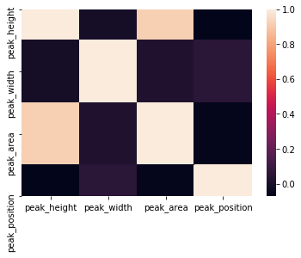

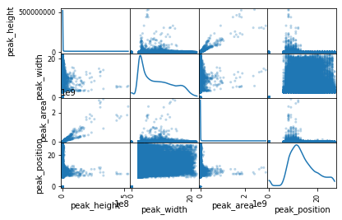

You can tell there is a strong correlation between peak height and area. This makes sense that area under our peak would be calculated based on height. Let’s remove area and see if we can see any other correlations once we break down the data to important compound to mass pair associations. I will use a heatmap and scatter matrix to determine correlations and the distribution of data related to each feature.

Mass pair ID: 0  
Compound id: 10

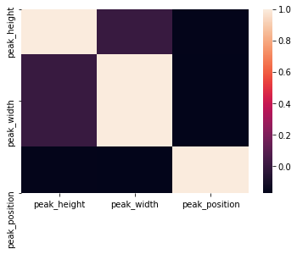

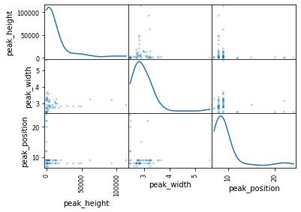

Mass pair ID: 2  
Compound id: 4

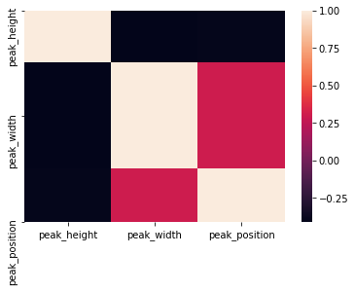

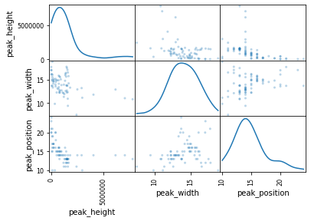

Mass pair ID: 3  
Compound id: 10

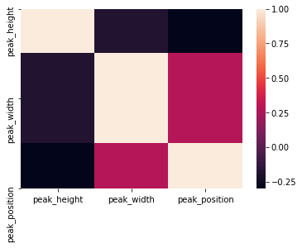

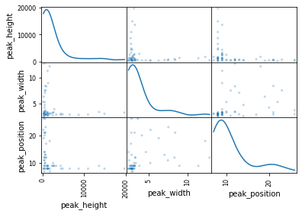

Mass pair ID: 4  
Compound id: 10

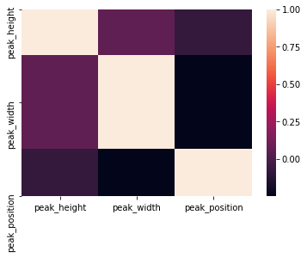

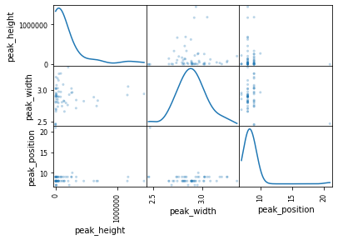

Mass pair ID: 7  
Compound id: 19

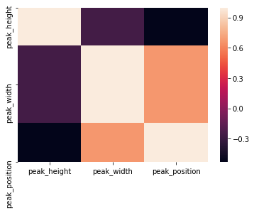

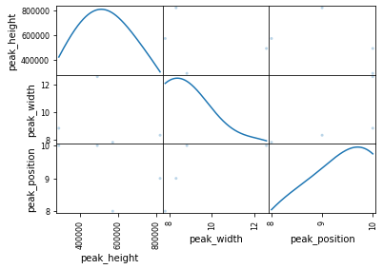

Mass pair ID: 8  
Compound id: 19

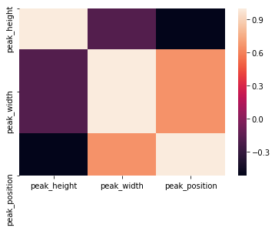

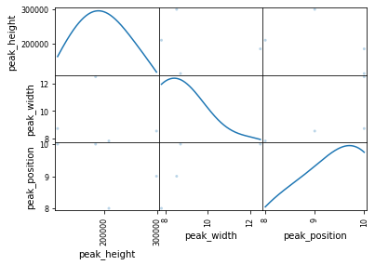

Mass pair ID: 11  
Compound id: 4

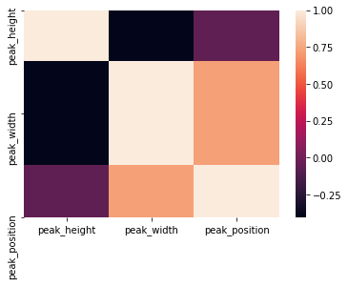

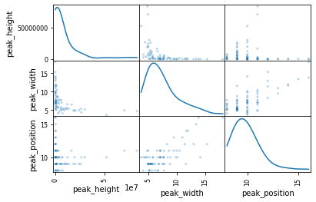

Mass pair ID: 16  
Compound id: 14

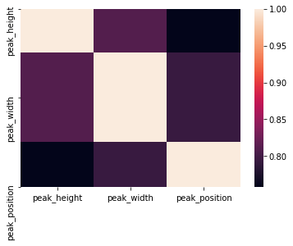

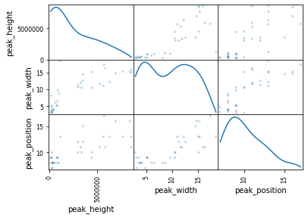

Mass pair ID: 16  
Compound id: 7

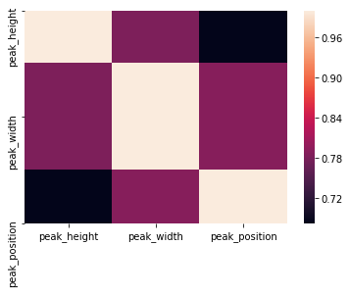

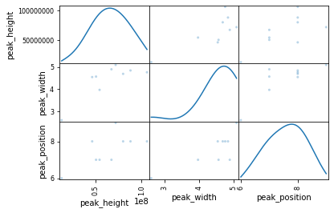

Mass pair ID: 16  
Compound id: 8

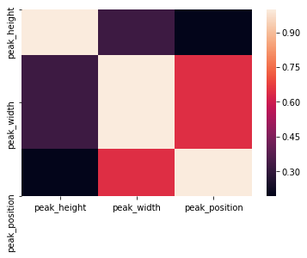

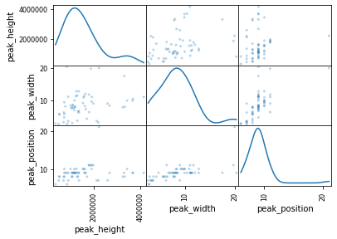

Mass pair ID: 18  
Compound id: 14

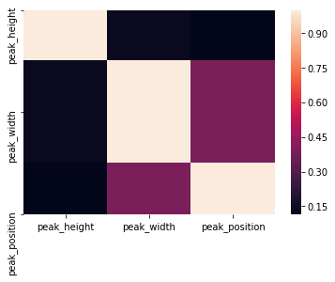

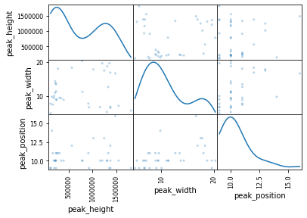

Mass pair ID: 18  
Compound id: 7

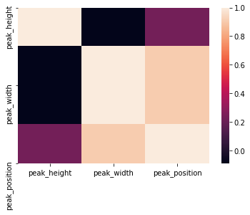

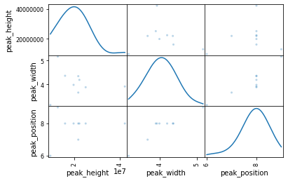

Mass pair ID: 18  
Compound id: 8

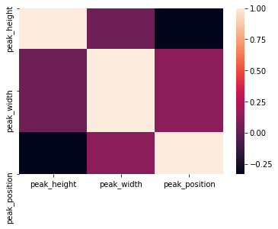

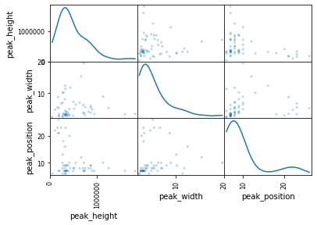

Mass pair ID: 19  
Compound id: 10

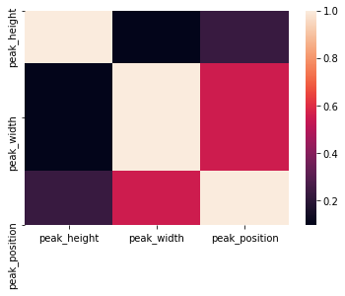

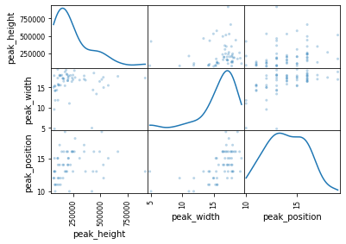

Mass pair ID: 19  
Compound id: 18

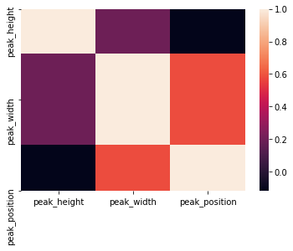

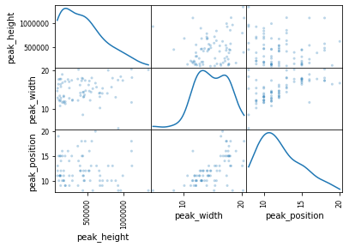

Mass pair ID: 20  
Compound id: 10

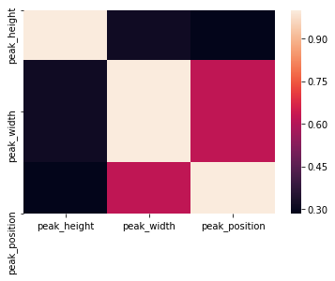

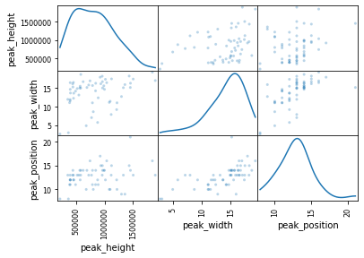

Mass pair ID: 20  
Compound id: 18

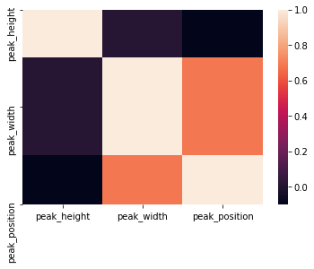

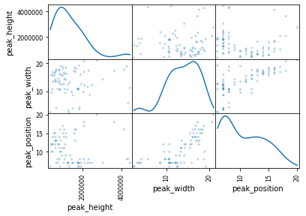

Mass pair ID: 20  
Compound id: 3

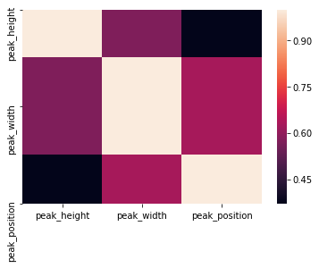

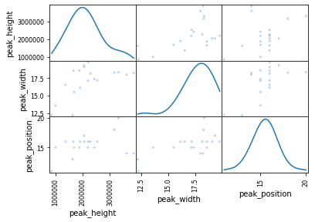

Mass pair ID: 21  
Compound id: 18

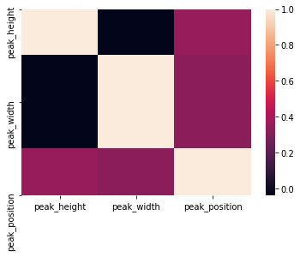

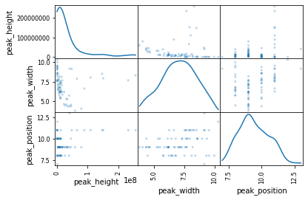

Mass pair ID: 22  
Compound id: 10

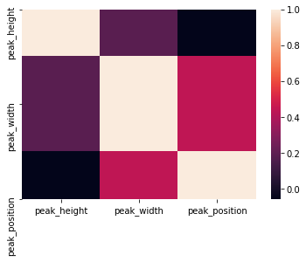

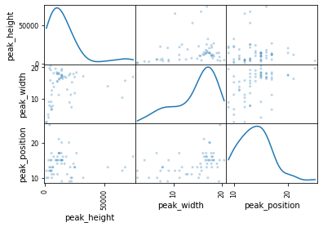

Mass pair ID: 22  
Compound id: 21

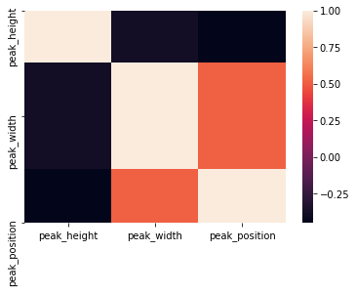

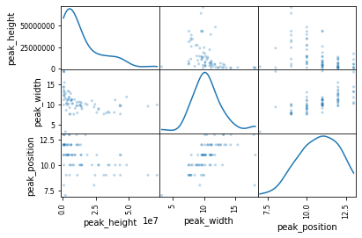

Mass pair ID: 22  
Compound id: 0





Mass pair ID: 23  
Compound id: 10

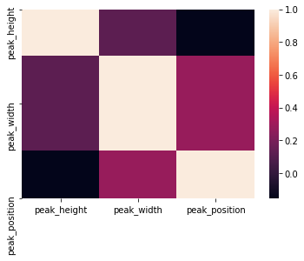

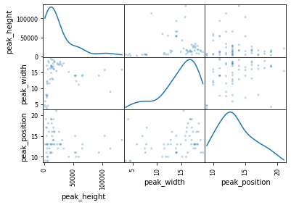

Mass pair ID: 23  
Compound id: 21

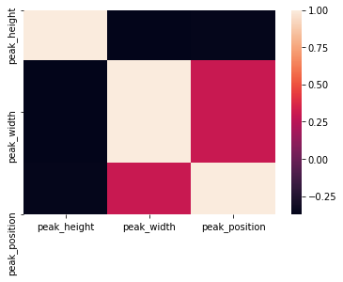

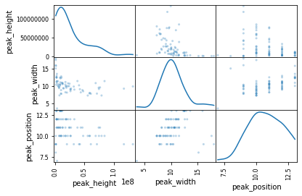

Mass pair ID: 23  
Compound id: 0





Mass pair ID: 25  
Compound id: 21

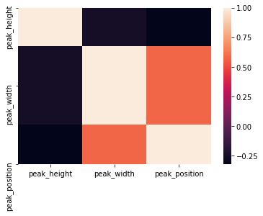

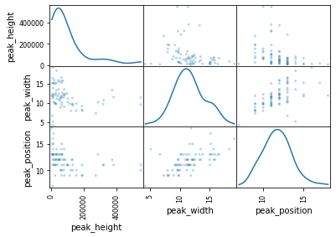

Mass pair ID: 25  
Compound id: 0





Mass pair ID: 26  
Compound id: 21

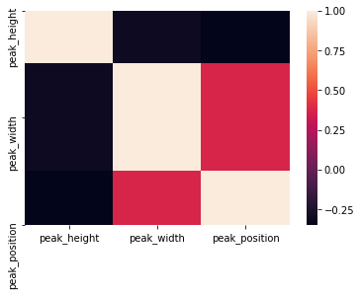

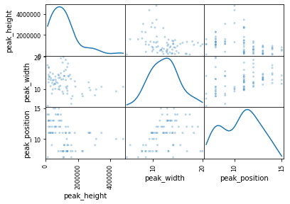

Mass pair ID: 26  
Compound id: 0





Mass pair ID: 27  
Compound id: 7

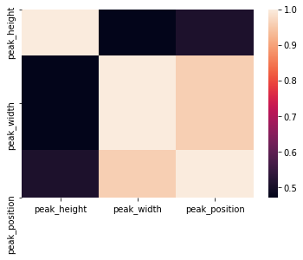

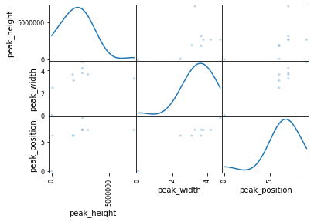

Mass pair ID: 30  
Compound id: 7

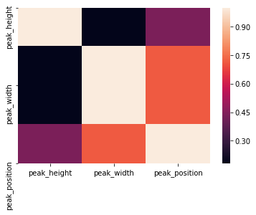

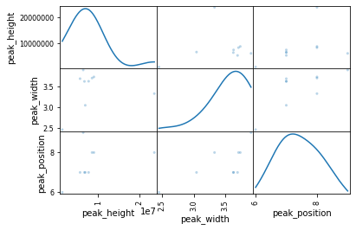

Mass pair ID: 33  
Compound id: 21

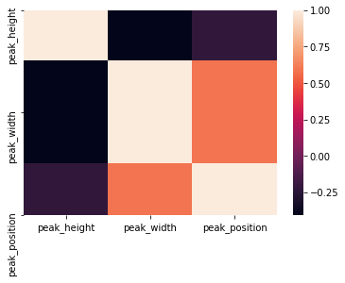

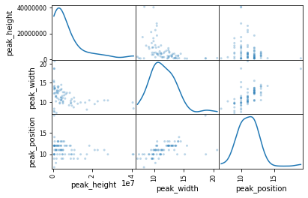

Mass pair ID: 33  
Compound id: 0





Mass pair ID: 34  
Compound id: 21

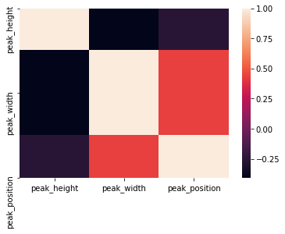

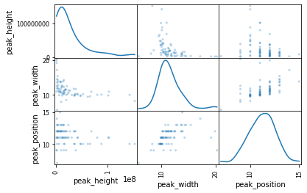

Mass pair ID: 34  
Compound id: 0





Mass pair ID: 35  
Compound id: 22

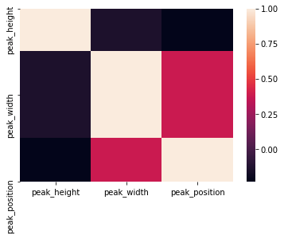

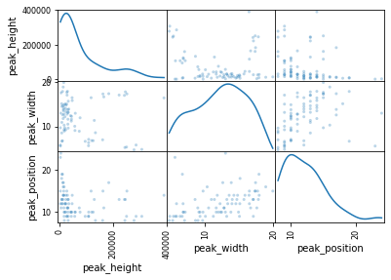

Mass pair ID: 36  
Compound id: 15

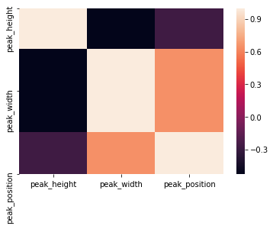

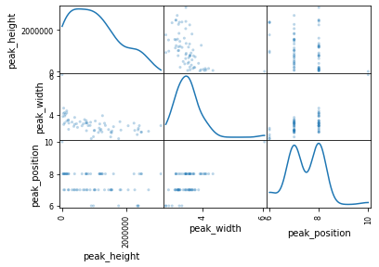

Mass pair ID: 37  
Compound id: 22

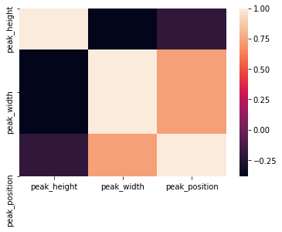

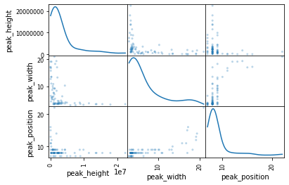

Mass pair ID: 38  
Compound id: 22

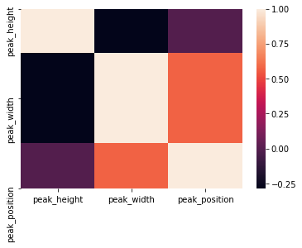

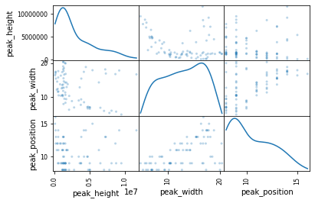

Mass pair ID: 39  
Compound id: 15

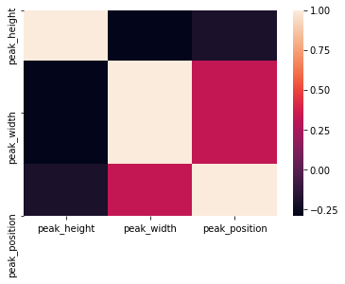

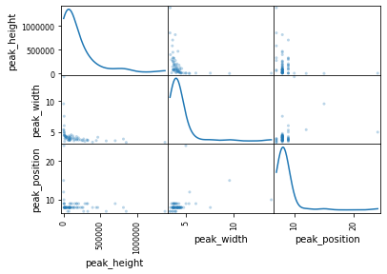

Mass pair ID: 39  
Compound id: 8

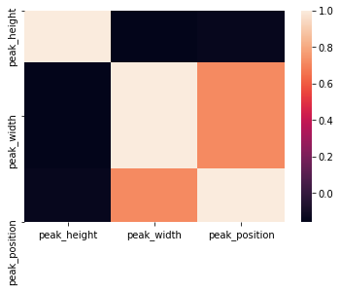

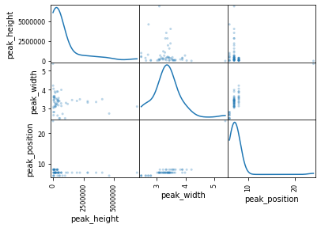

Mass pair ID: 40  
Compound id: 18

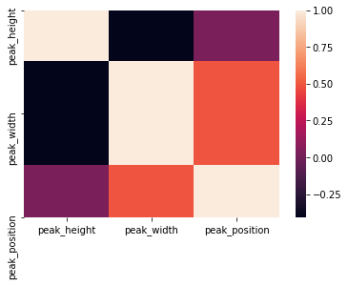

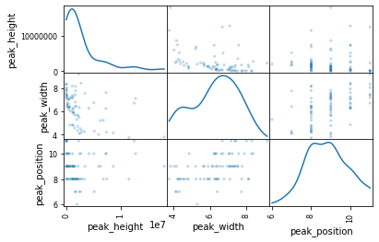

Mass pair ID: 41  
Compound id: 13

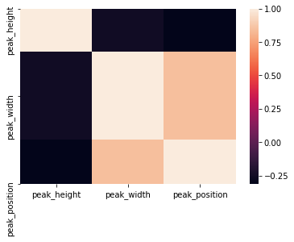

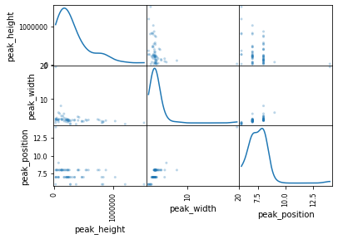

Mass pair ID: 42  
Compound id: 13

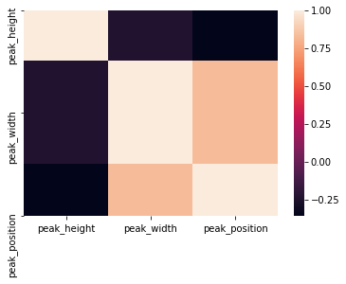

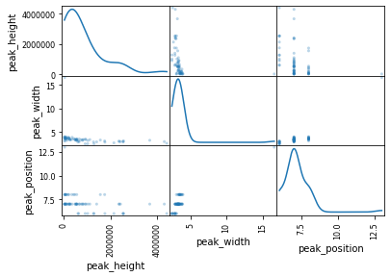

Mass pair ID: 46  
Compound id: 13

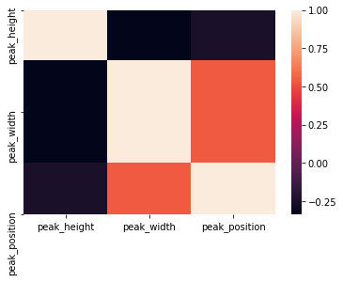

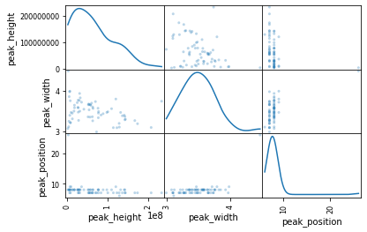

Mass pair ID: 46  
Compound id: 14

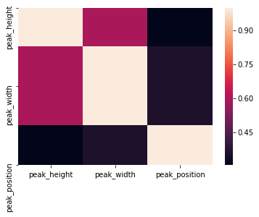

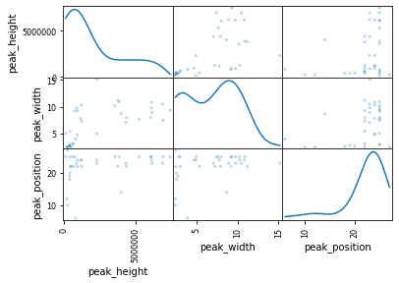

Mass pair ID: 46  
Compound id: 15

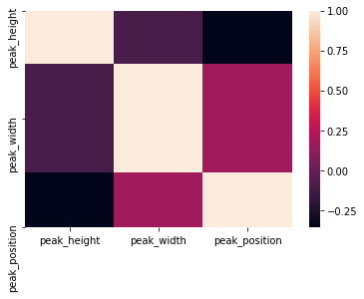

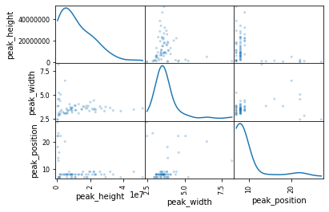

Mass pair ID: 46  
Compound id: 7

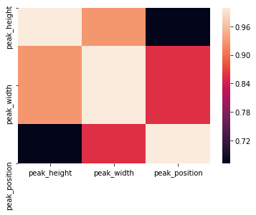

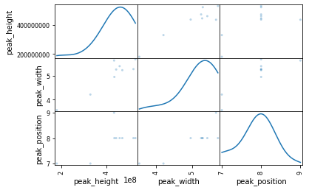

Mass pair ID: 46  
Compound id: 8

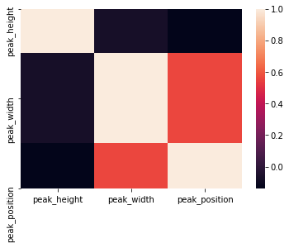

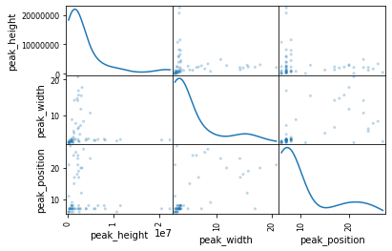

Mass pair ID: 47  
Compound id: 3

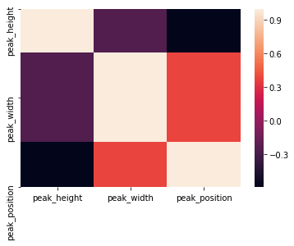

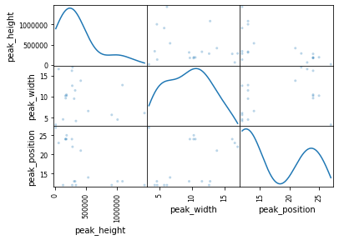

Mass pair ID: 49  
Compound id: 3

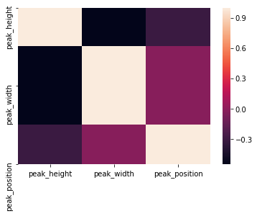

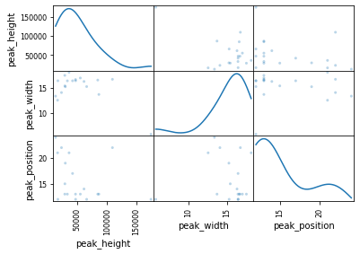

Mass pair ID: 50  
Compound id: 3

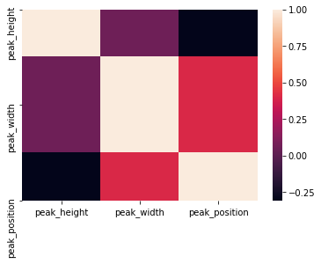

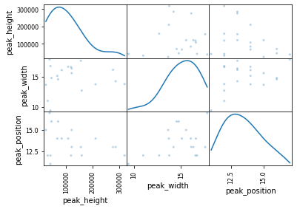

In most cases there is no other correlation. Some of the heatmaps show a little bit, but I think it could just be due to a lack of samples. Some of the scatter plots show a shifted gaussian curve, however, in other cases the distribution of the data looks non-gaussian. I am going to apply a log transform to see if I can change the data to be more gaussian.

Mass pair ID: 0  
Compound id: 10



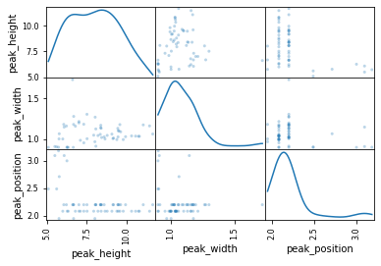

Mass pair ID: 2  
Compound id: 4



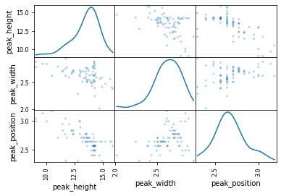

Mass pair ID: 3  
Compound id: 10



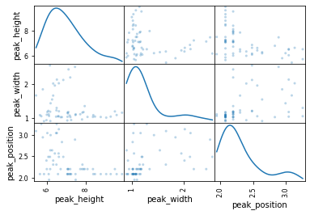

Mass pair ID: 4  
Compound id: 10



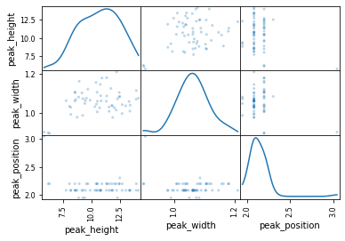

Mass pair ID: 7  
Compound id: 19



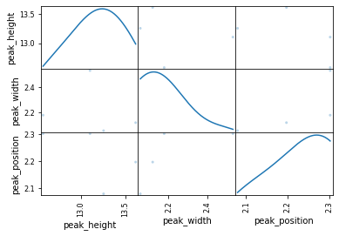

Mass pair ID: 8  
Compound id: 19



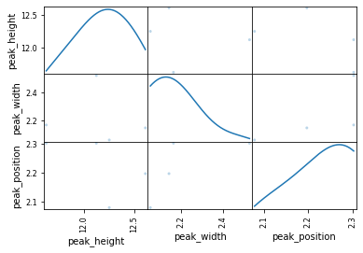

Mass pair ID: 11  
Compound id: 4



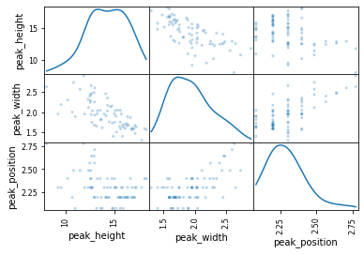

Mass pair ID: 16  
Compound id: 14



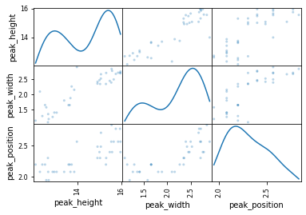

Mass pair ID: 16  
Compound id: 7



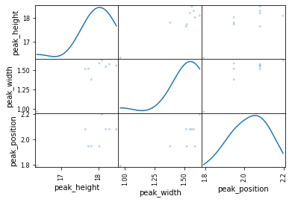

Mass pair ID: 16  
Compound id: 8



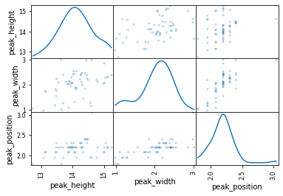

Mass pair ID: 18  
Compound id: 14



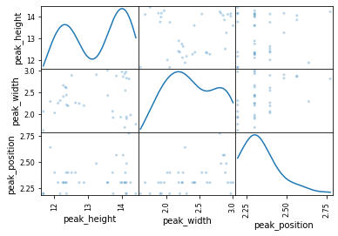

Mass pair ID: 18  
Compound id: 7



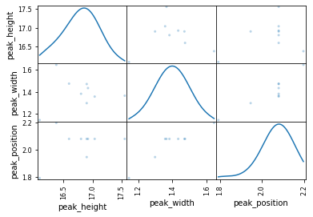

Mass pair ID: 18  
Compound id: 8



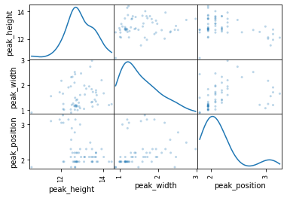

Mass pair ID: 19  
Compound id: 10



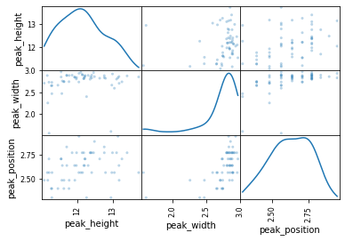

Mass pair ID: 19  
Compound id: 18



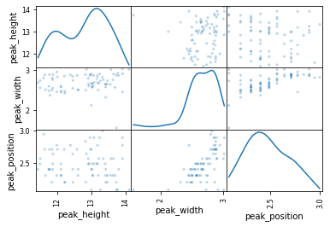

Mass pair ID: 20  
Compound id: 10



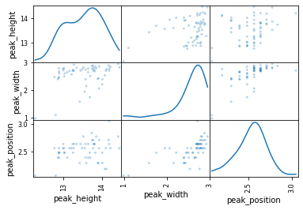

Mass pair ID: 20  
Compound id: 18



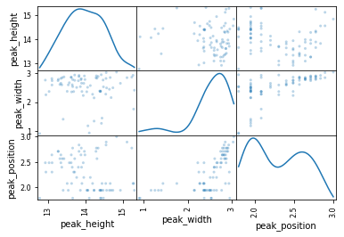

Mass pair ID: 20  
Compound id: 3



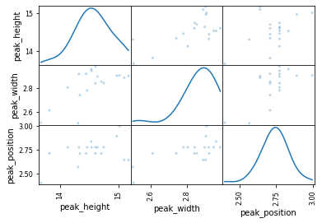

Mass pair ID: 21  
Compound id: 18



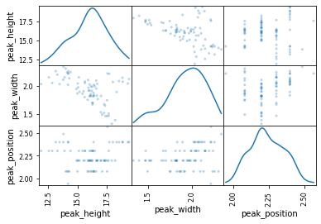

Mass pair ID: 22  
Compound id: 10



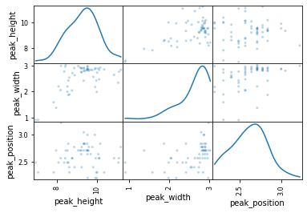

Mass pair ID: 22  
Compound id: 21



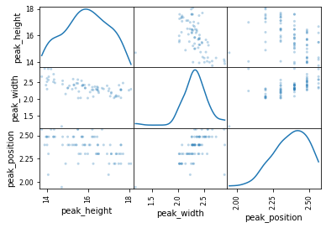

Mass pair ID: 22  
Compound id: 0





Mass pair ID: 23  
Compound id: 10



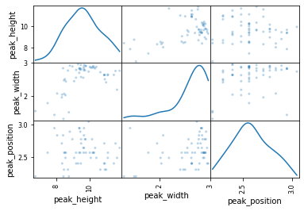

Mass pair ID: 23  
Compound id: 21



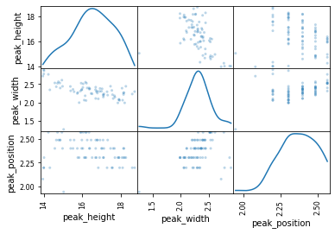

Mass pair ID: 23  
Compound id: 0





Mass pair ID: 25  
Compound id: 21



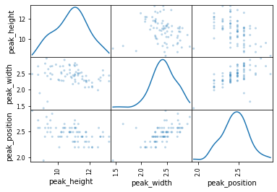

Mass pair ID: 25  
Compound id: 0





Mass pair ID: 26  
Compound id: 21



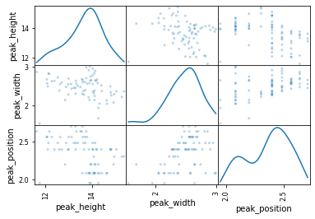

Mass pair ID: 26  
Compound id: 0





Mass pair ID: 27  
Compound id: 7

C:\Users\Brian.Mello\AppData\Local\Continuum\anaconda3\lib\site-packages\ipykernel_launcher.py:13: RuntimeWarning: divide by zero encountered in log  
 del sys.path[0]



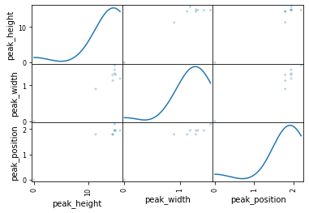

Mass pair ID: 30  
Compound id: 7



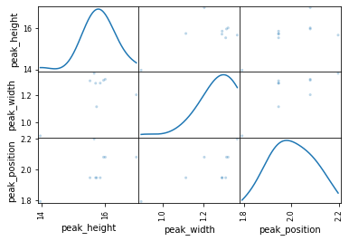

Mass pair ID: 33  
Compound id: 21



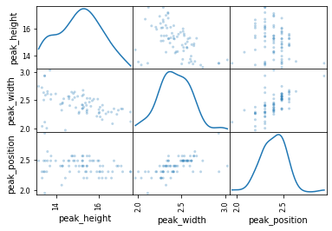

Mass pair ID: 33  
Compound id: 0





Mass pair ID: 34  
Compound id: 21



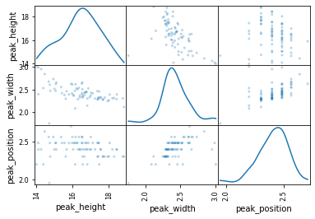

Mass pair ID: 34  
Compound id: 0





Mass pair ID: 35  
Compound id: 22



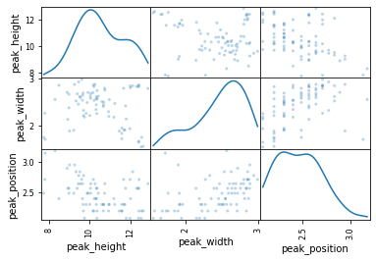

Mass pair ID: 36  
Compound id: 15



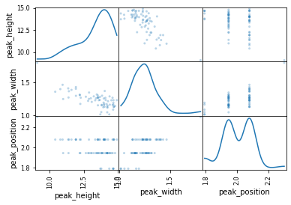

Mass pair ID: 37  
Compound id: 22



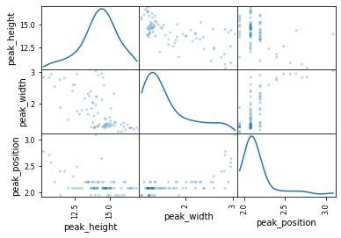

Mass pair ID: 38  
Compound id: 22



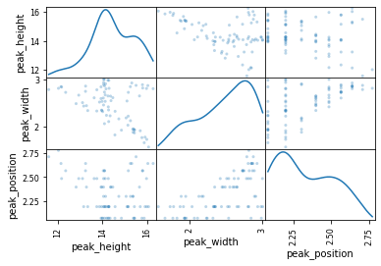

Mass pair ID: 39  
Compound id: 15



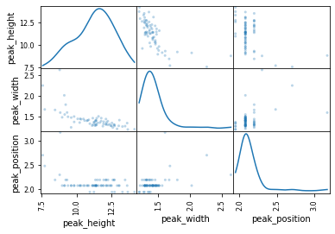

Mass pair ID: 39  
Compound id: 8



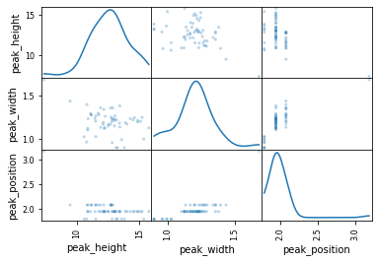

Mass pair ID: 40  
Compound id: 18



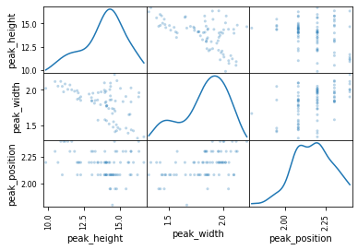

Mass pair ID: 41  
Compound id: 13



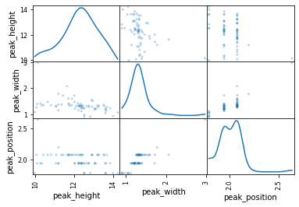

Mass pair ID: 42  
Compound id: 13



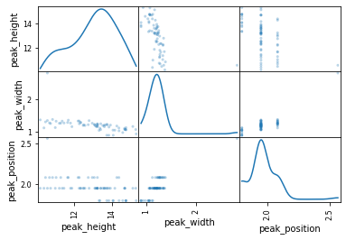

Mass pair ID: 46  
Compound id: 13



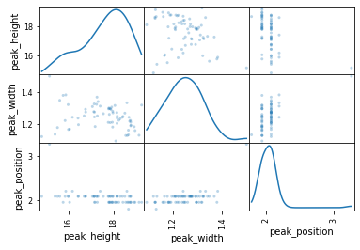

Mass pair ID: 46  
Compound id: 14



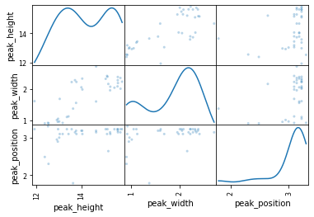

Mass pair ID: 46  
Compound id: 15



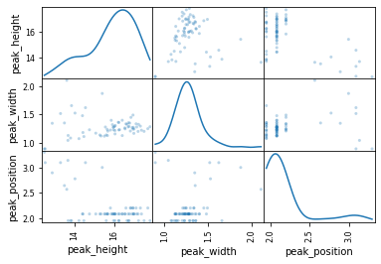

Mass pair ID: 46  
Compound id: 7



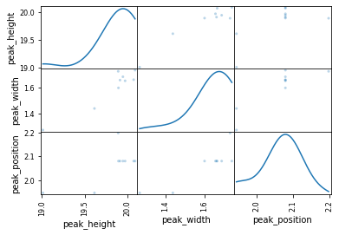

Mass pair ID: 46  
Compound id: 8



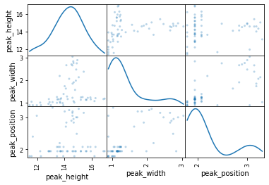

Mass pair ID: 47  
Compound id: 3



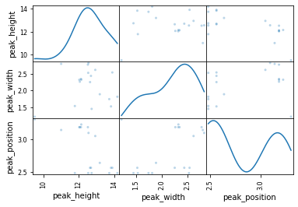

Mass pair ID: 49  
Compound id: 3



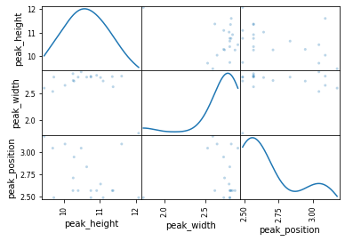

Mass pair ID: 50  
Compound id: 3



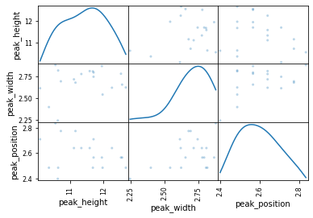

In some cases, the transformation of the data works well. In most cases it does not. It seems that either I do not have enough samples to represent the total population of samples or the current features are not deterministic enough to determine detections.

For the most part, width seems to be a very stable and independent feature. Position and height even though not correlated tend to mimic each other so I could probably get away with using either just height or position. I will try position because it previously had the least amount of standard deviation. Some of the mass pair to compounds are much more stable than others. On all cases, there are some outliers. Depending on the algorithm I use, I may need to remove these outliers to not overfit my model. Next, I want to plot and label all my mass pair data to get an idea of how well my algorithm will do on test data.

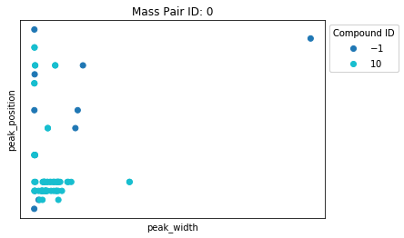

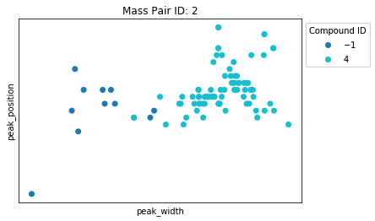

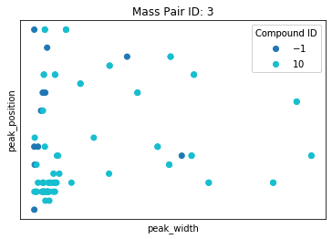

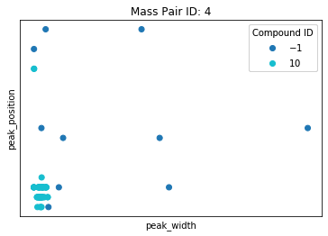

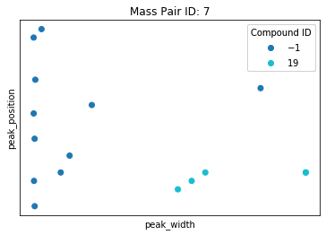

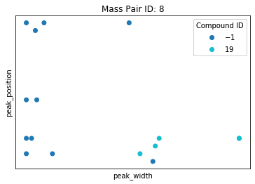

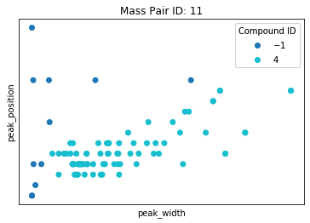

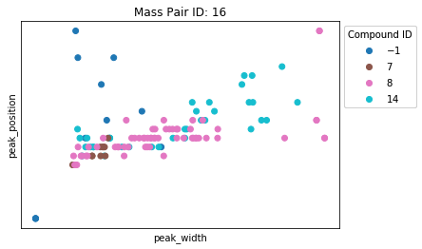

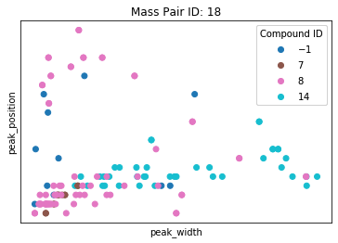

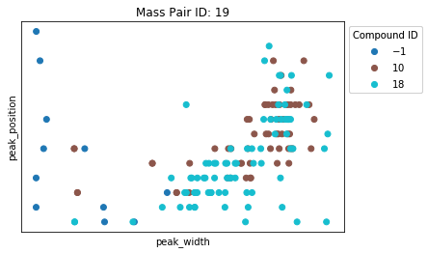

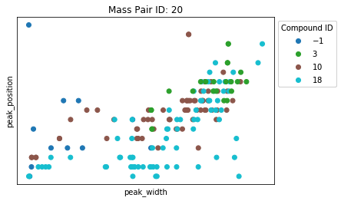

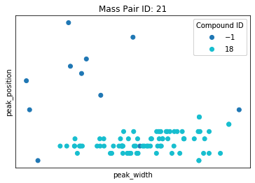

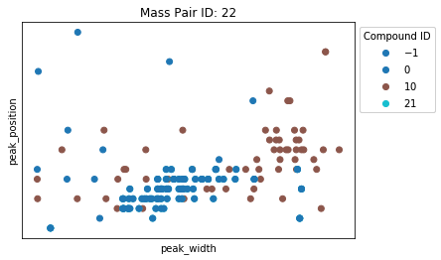

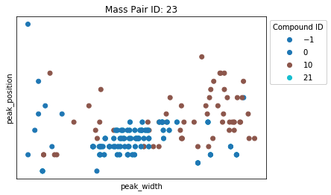

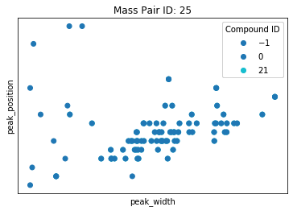

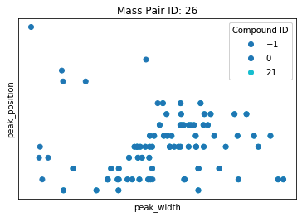

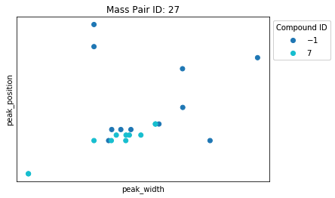

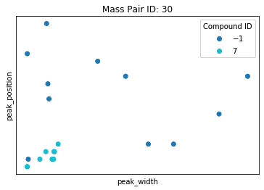

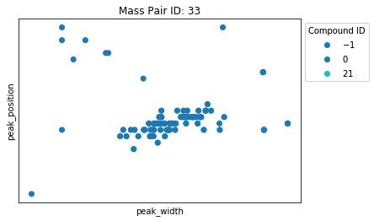

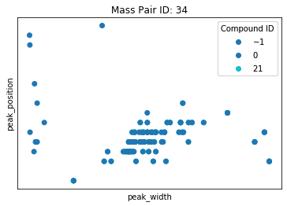

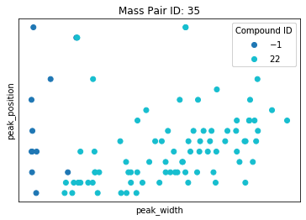

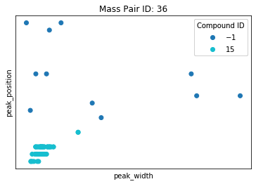

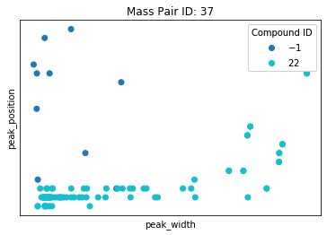

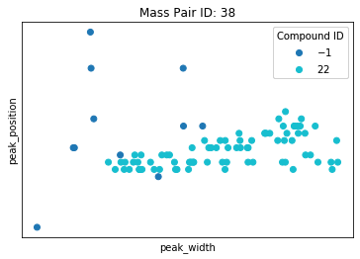

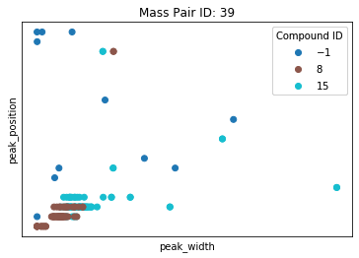

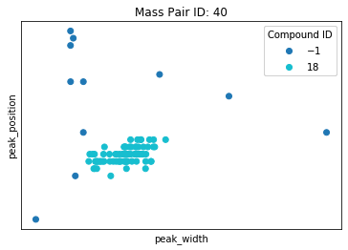

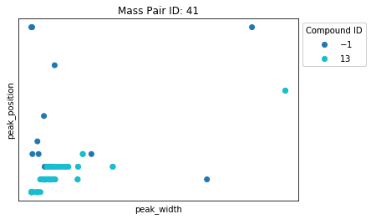

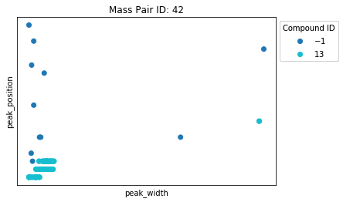

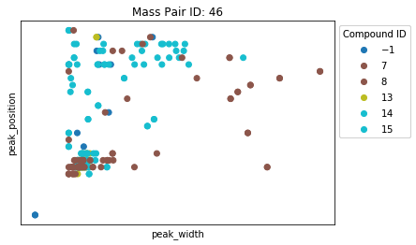

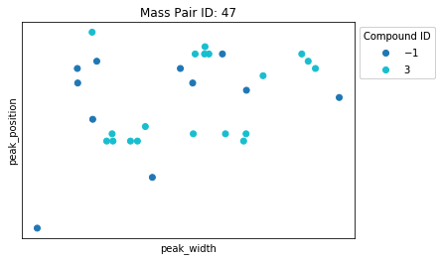

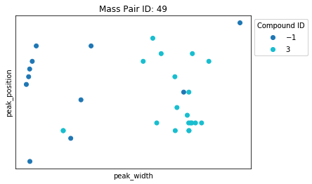

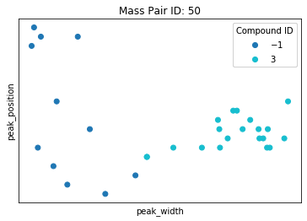

Some mass pairs look better than others. Let me see how height looks instead of position.

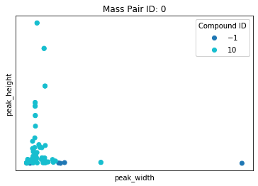

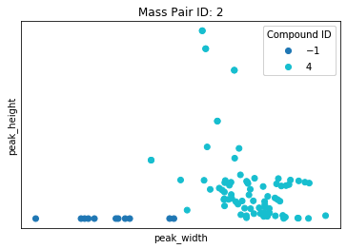

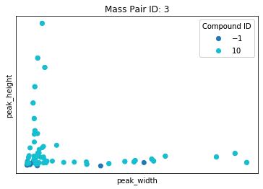

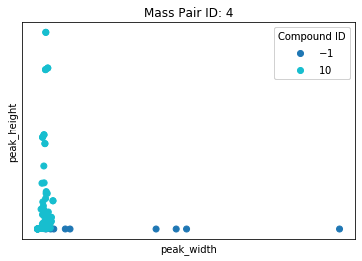

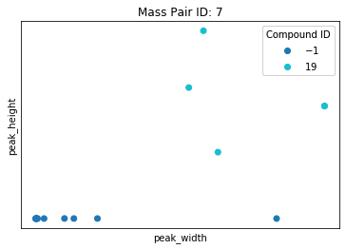

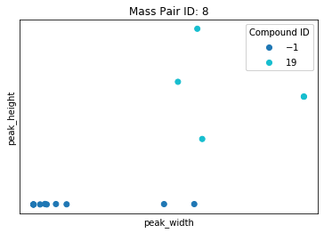

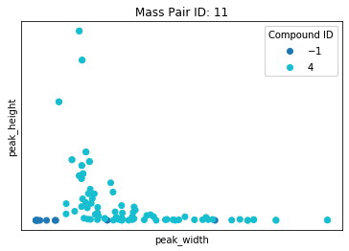

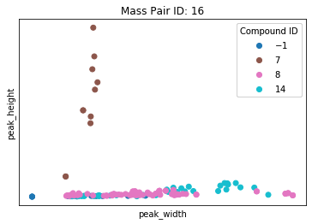

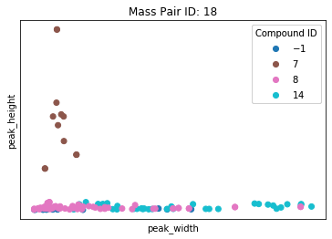

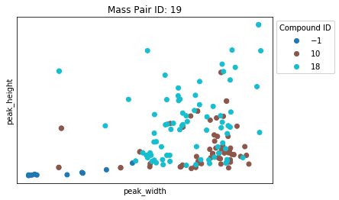

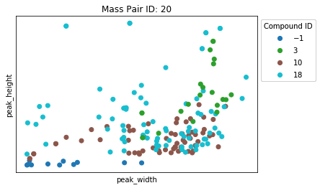

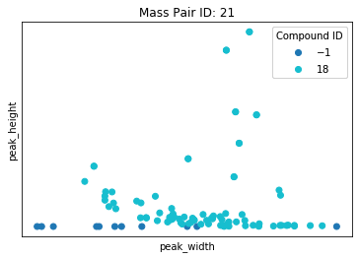

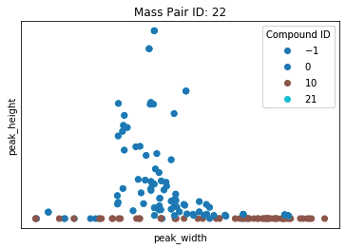

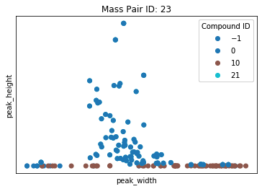

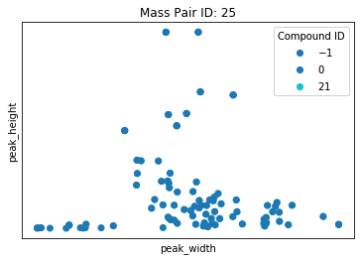

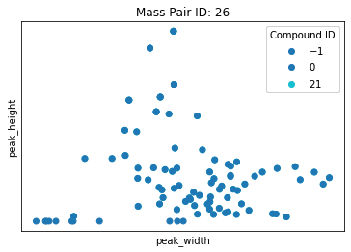

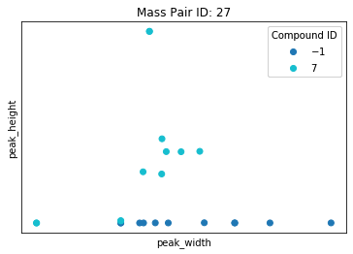

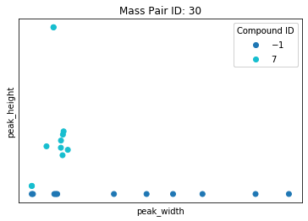

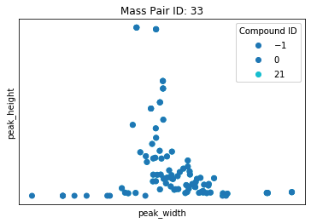

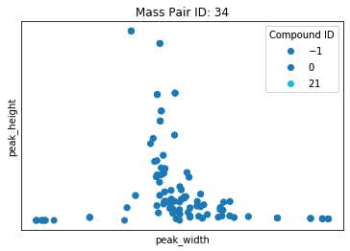

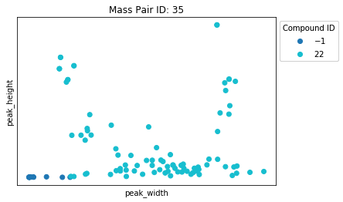

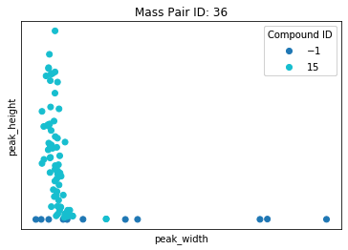

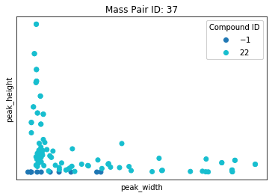

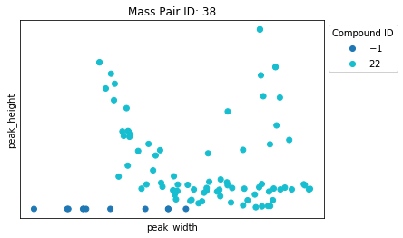

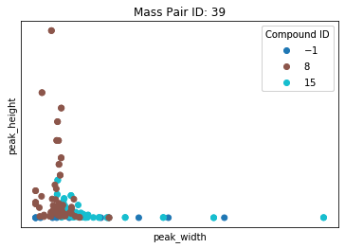

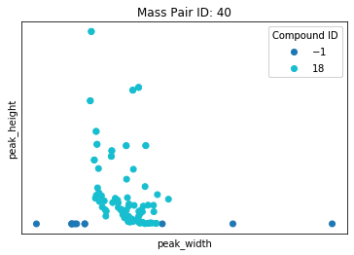

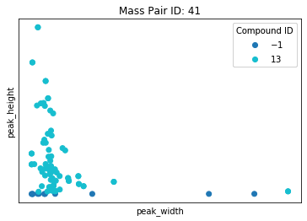

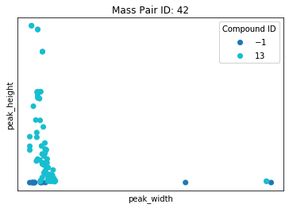

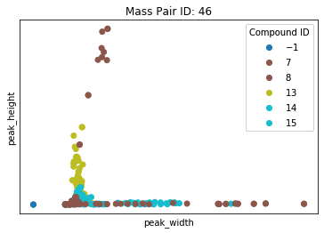

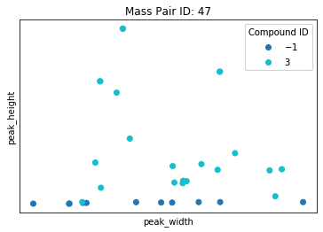

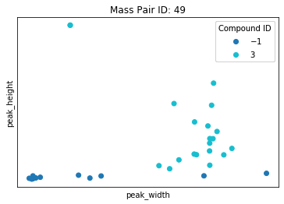

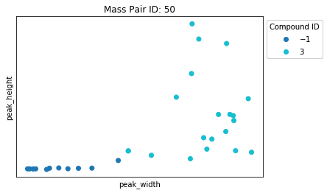

Algorithms and Techniques¶

In most cases, graphically height looks a lot worse than position as a feature. In both cases, the features seem less than ideal. Let's apply a polynomial support vector machine to the data. My hope is to create a very general classification that combined with all the associated mass pairs we can gain good results. Based on the data, it appears we could probably draw circles around pieces of the data, therefore, we could use a support vector machine (SVM) of either polynomial or RBF. RBF may overfit so I will first try polynomial and see the results. I will graph the classifications so I can see how well the algorithm fits per mass pair.

There are multiple reasons I would choose an SVM over other parametric algorithms. In most cases, the data is not linearly separable. This would rule out using a logistic regression algorithm or even a decision tree because a decision tree would probably overfit the data. Now another problem, I have is most of the data is not gaussian. Since it is not gaussian, I must be weary of creating classification lines that are too tight resulting in overfitting of the data. SVMs by design do not overfit the data because they try to maximize the margin between our 2 classes. By using a polynomial SVM I can transform the existing data into a higher dimension resulting in data that is more separable than it was before. This idea is called the kernel trick. In simplified terms, it works by taking the inner product of our data and using those values to increase our dimensionality hopefully creating a distinct decision boundary.

